Underlying the BA in Holistic Churchplanting and MA in Transformational Urban Leadership are a number of critical paradigms that all faculty and eventually students need to grasp.
Where is the wise man? Where is the Scholar? Where is the Philosopher of the Age?.... Christ Jesus, who has become for us wisdom from God (1 Cor 1:20,30).

The Purpose of the Degree
This is a leadership degree for pastors, workers, leaders from among the urban poor. Its primary aim is take those who have pioneered a church or a ministry among the poor and enable them to discern the whole breadth of issues needed as they move into leadership roles for wider urban poor religious movements, with concurrent diaconal ministries. Its aims are
Primarily, to take those with pastoral, teaching, evangelistic, apostolic, and prophetic giftings and facilitate the expansion of these into wider leadership roles across movements. Apostolic leadership is servants leadership, that establishes multiple structures (churches, projects, NGO’s, businesses), gives vision, values, culture and leadership to these through a lifestyle of preaching, teaching, sacrifice, suffering and obedience to the voice of the Holy Spirit.

Secondarily, to take those with diaconal giftings (spiritually motivated roles garnering resources from the rich and management of their distribution to the poor) and expand them from small projects to movement-wide roles - be that within churches, NGO’s or civil society roles. Unlike many training courses in community development this is to be accomplished around the core of the spirituality of religious movements of the slums.

The Locus of the Degree
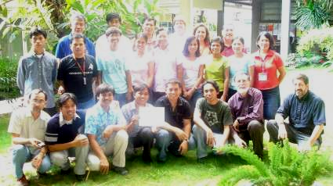
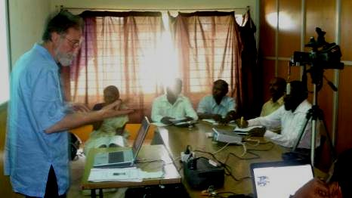
The first purpose relates to the locus of the degree. This is not primarily a degree for middle class people who wish to improve their status. It is a degree for the poor and those living and working among the poor. Middle class people who wish to serve the poor on the terms of the poor (such as young American grad students or staff from Western-funded NGO’s or middle class pastors) are welcome to come and observe, but the processes belong to the poor. This was a foundational principle for Jesus – his education was for the poor and among the poor and he chose to live among the labouring poor. This is in contrast with most degrees in social work or community development which are largely degrees for the middle class to serve the poor.
Jesus’-style Seminary in the Slums 2:
Underlying Philosophy
Why is this Program so Revolutionary?

There are implications to the above statements. One of them is that text books need to be screened to see if they are predominantly based on the stories of the poor, or based in the locus of the educated class delivering solutions for the poor.

Incarnational Learning
The incarnation was defined by John (1:14) “He dwelt among us”. Later Peter would say, “we touched him.” The processes of following Jesus in his living as a labouring poor man among the labouring poor, are not always ideal. But we seek in the degree to move to the ideal through processes of identification, relocation, or incarnation.

Without incarnation, the church is not formed among the poor.

Indigenity and Globalisation
The above indicates a preferred option for knowledge from the indigenous people, the slum in the local context, yet we have also chosen a global consortium, in order to validate the local with global knowledge. Each course draws on local literatue as well as participants stories, but equally seeks out global literature. Each school emerges the program within its own paradigms but we choose to work together through a commission to maximise the value of global knowledge and personell.

Story-Telling Holism
Another paradigm is that of story-telling. I was in Manila at the launch the MA in Transformational Urban Leadership, preaching about the passage above and the contrast between Jesus’ style education and the education of the academe. For Jesus was an educator - a brilliant mind. He recruited learners around him.

He knew of the Greek philosophic systems that Paul rejects here, and could have taught within them. For he grew up in the Decapolis, (10 Greek cities), lived 4 miles from Sapporis, one of these leading cities, where all the philosophies of the world crossed. He maybe built houses there. But he chose a different methodology for his educative process. It involved action-reflection more than philosophy, and built from the stories of the people, proverbs, and parables as these interfaced with God’s story and the conundrums of the trinity.

Following Jesus in the 21st C context, this MA is an action-reflection degree built around a process I call Transformational Conversations, a process of discerning truth through holistic story-telling. Some academics think this is not kosher. That truth can only be found through Platonic logic. Jesus was smarter. It’s the same argument Paul also is addressing.

Theological Premises
The above indicates some underlying theological premises as to the proper locus of power for both transformation and education.

- An understanding that Christian societal transformation is based on the power of the preached word breaking open new paradigms, new lifestyles, and releasing lives of creativity and productivity.

- An understanding of the centrality of the power of the Holy Spirit in individual and community transformation, in his daily work of leading, empowering, counseling, comforting, revealing, envisioning the future.

- An understanding of the central role played in societal transformation by religious movements among the poor, as these create a societal base of transformative values. This is particularly true of movements of communities of faith or churches in churchplanting movements.

- An understanding that these are all within a framework of what has commonly become called holism, or integral mission, resulting in transformation of societal structures and values. This degree recognize that such transformation largely derives from the above preached word, power of the Spirit, released in movements of communities of faith among the poor that result in social, economic, political discipleship built on the core spiritual values. Unlike programs on community development for NGO’s whose task is largely delivery of diaconal services, this program does not understand evangelism and church multiplication as an adjunct to diaconal delivery but as creating the central elements of people empowerment.

An understanding that this is healthy tension with the nature of transformation of poverty by the middle class and wealthy as they create redemptive structures among, or for the poor and control the nature of words that describes such transformation, thus skewing the global literature in favor of middle class perspectives. These middle class 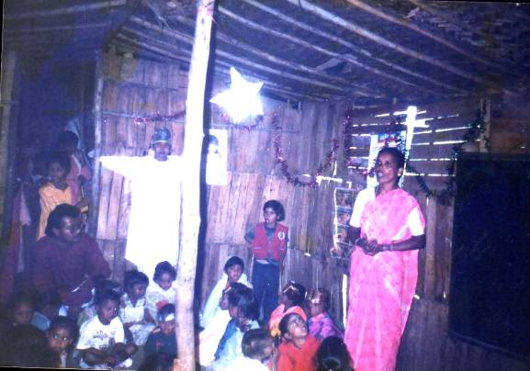structures are healthy applications of the word often in secular forms. There are middle class and wealthy who will enter this program in order to develop skills in such diaconal or justice-oriented processes. However given the central understanding of the transformative power of the word, the Spirit and faith community among the poor, we live with a constant pressure from the highly funded NGO’s to see the diaconal as all in all. We explicitly seek to resist such pressure and to keep these centralities yet train students in the complexities.

Outcome-Based Training
Thus graduates will be seen as effective, if they know how to apply the word of God to the complexities of the urban poor life around them, walk in the brokenness of a Spirituality that draws on the power of the Spirit, are extending religious movements among the poor in weekly evangelism, Bible Studies, faith community formation, yet doing this in the context of encouraging their workers in a diversity of holistic ministry directions.

Unlike development degrees and MBA’s, this is not primarily aimed to produce mid-level managers of NGO’s, though that is not excluded.

Apprenticeship and Mentoring Disciplines
This degree is based on an interface with a Jesus-style training process and the academe. Jesus not only taught but mentored over three years in the disciplines of evangelism, disciple-making and formation of faith communities.

This underlies the field education courses of the degree, which include each student being mentored throughout the degree in a churchplanting team context in the weekly disciplines of evangelism, small group formation, discipleship, and creation of new faith communities.

This is personal, and relational transferral of spirituality, values, vision, disciplines, skills, and character.

Similarly, much of the poverty of the slums remains for decades for lack of understanding of the fundamental economic principles of the universe as revealed in the scriptures. Teaching these alone is inadequate. Mastering these requires mentoring by those successful in economic principles. This occurs across 18 months of the degree as part of the Field Education and the two courses on Kingdom Economics and Organisation and Entrepreneurial Leadership.

The third main area of mentoring is in spiritual growth, beginning with the Urban Spirituality course, and through an ongoing relationship with a spiritual mentor selected by the student.

Action-Reflection Theology
Urban missiology is by definition activist, in the context of rapid change. This reflects the nature of the Bible God, the urbanizing God, the creator God, who continues to establish systems of productivity. The nature of knowledge that the scriptures propose, is the knowledge that comes from obedience in action. Indeed Jesus approach to learning the nature of God is predicated on active obedience as foundation. “If you keep my words, you will know the truth, and the truth will set you free”.

This contrasts with Platonic differentiation of pure knowledge from action, and hence this style of action followed by Spirit-directed and communal reflection, raises hackles among those trained in “pure” academics, “pure” systematic theology. It is in fact a gauntlet which states that such purity is less than Biblical, and does not lead to knowing the nature of God. We do not intentionally set out to offend but in this degree we will insist on academic credibility on this point, that almost all courses begin in action, then move through reflection to further action.

Character Precedes All
The modeling of Jesus, the emphasis in the writings of the Apostle Paul, the thrust of the Old Testament, indicate that the training of the character of a leader is more important than the information or skill passed on. Robert Ferris identified this as a critical element in the success of Seminary graduates. Thus the majority of courses have an emphasis on character formation in their defined outcomes.

Such character is the work of the Holy Spirit, so training in discernment of his ways is a critical dimension that must be integrated into many of the courses.

Viv Grigg, B.E.E., M.A.(Missiology), Ph.D.(Theology)
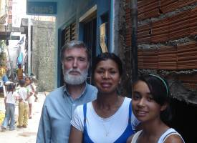
Viv Grigg has been an activist pioneer of churches, urban movements and development processes. In his leadership he has utilised story-telling consultations and action-reflection processes in the formation of city leaders globally and urban poor leaders in the slums (2250 this year in 19 cities). He developed the paradigm of Transformational Conversations as a primary way of doing Urban Theology.

