The Radical Discontinuity of Jesus’ Seminary in the Slums
Viv Grigg

Where is the wise man? Where is the Scholar? Where is the Philosopher of the Age? .... Christ Jesus, who has become for us wisdom from God (1 Cor 1:20,30).

Among other things such as being God, Jesus was a brilliant educator, and director of a school. He modeled theological educational approaches among the poor. Traditional seminaries descended from the Western Platonic academe as it has come through Catholicism and the Reformation come from a different philosophy and practice. They may want to follow Jesus, but it requires a radical discontinuity. What opposition are you likely to find, if your seminary was to seek to follow Jesus in his simple philosophy and practice?

For hidden in the previous article on the style and content of Jesus’ Seminary in the Slums are some radical implications for the structure of seminaries. I have deduced these in italics below.

He recruited learners around him and mentored them in action. Mentoring as a primary educational mode as against mentoring as an additional element in a course of didactic learning is rarely seen across evangelical educational institutions except in areas of social work or urban missions or … Facilitators of such courses will be experienced practitioner-reflection leaders or will have to be willing to invest the time in being trained in these methods. Course location needs to be decided first, with a secondary location for reflection.

His style of action-reflection learning begins with engagement of the needs and the slum community. This leads to a period of reflection on the action resulting in a new theological formulation related to the arena of action. This could be a situation of oppression of the poor by the rich sending in bulldozers to take their land for condominiums, or a Ugandan slum pastor training 40 other pastors how to care for AIDS victim. Community, then classroom reflection on these issues each generates the formulation of aspects of slum-dweller’s theology. Action-reflection education will need to be lead not by an expert instructor but by an expert facilitator of reflection who can easily move back and forth from his/her base of expert knowledge to a mode of facilitative reflection on experiences. Each course will need to have facilitators with the theological skills to do this and the expert technical experience of the subject matter. This may need to be a combination.

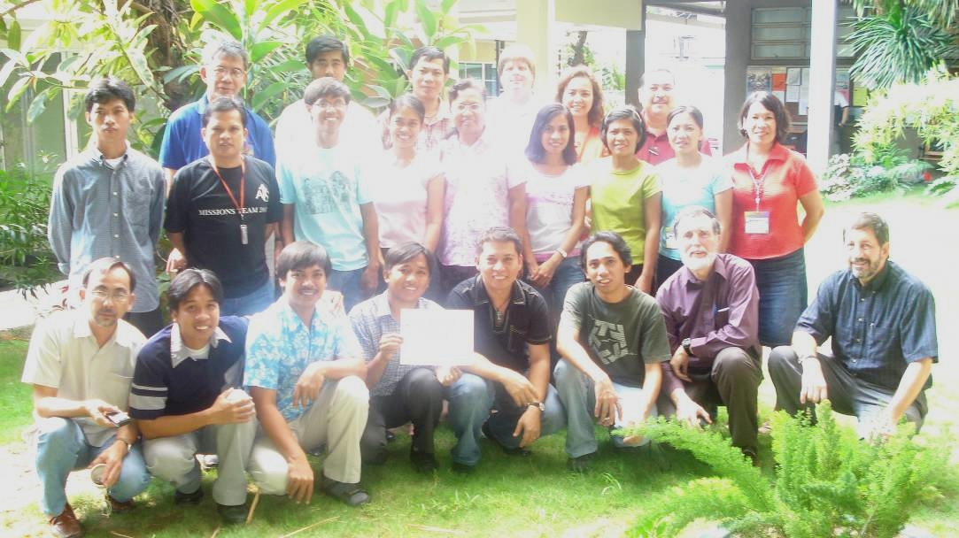
The implication is that after a brief introduction, each course begins with action and engagement, continues with extensive practica, then moves to classroom reflection and engagement with the literature. It is not surprising that Freire (1986) discovered this some centuries after Jesus. His paradigm-shifting educational ideas give academic validity to such a shift in style. The experiences of Latin theological educators, particularly the liberationists, who have sought to follow his approaches, gives some degree of modeling (success, failure, deviation), against which evangelical following of Jesus can be measured (See Van Engen (1994) for an evangelical extension of their hermeneutic cycle. It requires facilitators to write course outlines that first outline the practicum then the way the facilitator will integrate from practice to teaching and reading.

Which indicates another dynamic – the location of Jesus’ theological reflection is first at the locus of the poor. Guitierrez and Boff were simply following 2000 years of radical discipleship when they brought that to the attention of the Latin theologians. One implication is that students be required to live among the poor (or next to the poor if conditions do not allow incarnational approaches but only identificational approaches (see (Grigg, 2004) for the issues in modeling of this)). Some encourage engagement in the daily life of poor communities. Engagement in daily night life is far more strategic. Facilitators for most courses also will need to have had extensive experience living among the urban poor. There are few theologians who have done this. Thus a whole new cluster of practitioner-theologians will need to be recruited, initially as adjuncts. I have had 30 years of experience with those who have not identified with the poor being vehement in their opposition of incarnational models. Justification of securities or even affluence is inherent in our humanness. Such opposition needs the grace of a St Francis. While the attacks are often vitriolic, graceful responses and small engagements into the slums of those who oppose is a wiser response than rhetoric. Faculties are brotherhoods and sisterhoods.

Comparison of such theologies for validity is largely synchronic, as urbanization and the extent of urban poverty is a new phenomena. But both diachronic (traditional, historic) validation and synchronic (across cultures, present) require evaluation of the global literature. The implication is of a local to global reflection process. Local experience, local reflection followed by the facilitation of a conversation between that reflection and the global literature. Library facilities need to be stocked with both the local conversations and the global literature. There are a number of areas in the courses outlined where such literature is largely unavailable, still in oral form. Some new fields of knowledge will be developed.

Freire realized that the poor learn from their own stories. This MA is an action-reflection degree built around a process I call Transformational Conversations (Grigg, 2000), a process of discerning truth through holistic story-telling. Some academics think this is not kosher. That truth can only be found through Platonic logic. Jesus was smarter. It’s the same argument Paul also is addressing. How then do you retrain faculty from their experience under didactic methodologies into facilitators of conversations, built around webs of belief in a holistic manner (Grigg 2004b)?

The previous article indicated that Jesus’ syllabus was very different to classical theology derived from Platonic/Catholic/reformation traditions. It began with 40 days of prayer and fasting, so we begin with Urban Spirituality. But spirituality in the slums has a major disconnect from classical spiritualities. It is noisy, emotional, full of direct encounters with the power of the Holy Spirit, with the weeping and orality of the damaged, and deliverance and healing are normative. Those trained in “spirituality” think they know the field but Western models of individual reflection and quietude, while significant and important for worker survival among the poor, are a world away. Which seminaries train people in direct work with the Holy Spirit in healing and deliverance? In character development from backgrounds of rape, violence, the psychological damage of poverty? What opposition would you expect from those trained in a spirituality based on individualism, order, quietness, the desert?

7 years of consultations across 20 cities with urban poor church-planters and movement leaders, and leaders of holistic NGO’s among the poor resulted in initially 23 courses reduced to 16 for manageability. But Rescuing the Marginalized – prostitutes, street children, drug addicts, Advocacy and Land Rights, Innovating Slum Education etc may seem far away from Hermeneutics, Homiletics, Systematic theology 1, 2, 3, 4, Church History 1, 2,3, Philosophic Theology. They are. And the distance will immediately invoke opposition. Are these theological courses? Why are they not already in our hundreds of years old curricula? How do we add these to an already full traditional curriculum? Is not a solid biblical knowledge and basic understanding of systematic theology a foundation for a contextual theology? (After identifying desired outcomes over some years from the grassroots, a Biblical overview was included as the first course in the degree - but it uses Rob Bellingham’s overview of the stories of the Kingdom in Genesis, Exodus, Leviticus... Revelations, as the Kingdom interfaced with creating a new community, turning a slave people into the people of God, deals with oppression, urbanization, etc…(Bellingham 2007). But we expect that each school, with their expertise, will add at least an introduction to theology course and some want to add urban poor hermeneutics, an introduction to missions, an introduction to world religions, some accrediting bodies want an extra paper on research, and academic English. It becomes a question of extending a 45 unit degree to 60+ for adult learners, leaders who already have ministries, are working jobs and leading families. So program directors have a fight on their hands to keep it within reason.

Secondly, holistic story-telling, what I have called “Transformational Conversations” as doing theology is a completely different way of grasping theological truth. The style with which we “do theology” instead of “think theology”, working in each course from multiple stories in order to find multiple perspectives, then contrasting those stories and perspectives with the Biblical stories to develop a transformational story - such a style does not have that refined book-learning centre, and does not follow Platonic logic. It follows a logic of discerning truth holistically through obtaining sufficient and sufficiently diverse but interrelated stories to identify a web of truths on a particular arena of knowledge (See Grigg, 2004). The Greek philosophers told us this was less than the higher truths of rationalism. Perhaps. But perhaps grasping primal understandings of truth in communal contexts is not a lower level of knowledge, but closer to the intuitive sensing of knowledge that some modern philosophers identify as near epiphanies.

This does not mean that “higher level” logic is totally rejected. We have to live with the reality that Plato also lives in the academe. There are some courses that may be better taught from this perspective. Jesus discussed ways of understanding the signs of the times, so a course on Urban Realities and Theology helps students understand the context of the city and poverty, and that requires some introductory understanding of complex issues and the logic behind them. Issues of Advocacy and Justice connecting rich and poor, were important to him. Certainly the Integration Project or thesis requires students to interface with the academe, so each course needs to train a masters student step by step towards capacity to write with logic. We are starting with poorly educated leaders, so the course coordinator will need to make sure that in the integrative field education courses each semester, there is personal mentoring in processes of logic and writing. Some schools will include this in additional English (or Portuguese or...) for academics courses.

He expected his disciples to bear much fruit. The core of the degree is taking emergent or proven leaders and facilitating them into movement leadership skills. Movement Leadership grapples with multiplication. As such it has seemed best to position this degree as a leadership degree rather than a theological degree. We know that it is deeply theological after the theological method of Jesus, grappling with the whole of the scriptures in a conversational engagement across multiple fields. But since not all faculty would agree it seems simpler to set it to one side of the theological institutions as a specialist urban missions or urban leadership degree and since few faculty are trained in Jesus-style education to recruit a whole new bevy of adjunct facilitators gradually moving a core of them into full-time roles as well, in order to stabilize the program, and interfacing them with the traditional theologians so as to minimize the tensions. This is not an end-run around existing faculty for they will always be, but just a part of a process to sensitively move the balance from Plato to Jesus.

In summary you will need to:

Re-Faculty
- Find new practitioner-theologians as adjuncts, then staff
Re-Learn
- Train new faculty in facilitative learning
- Train new faculty in action to reflection processes
- Untrain faculty in didactive classroom emphases
- Train new faculty in utilising of transformational conversational theology
- Train faculty around structuring mentoring experiences as a primary methodology
- Coordinate faculty in structuring practica for most courses (employ a coordinator)
- Train students with high intelligence, motivation and skills but little academic background into the logic of the academe over two years
Re-locate
- Require faculty and students to relocate in or near the poor
- Relocate both practica and reflection into the slums themselves away from the sacred halls
Re-theologise as a school
- Deal with conflict with existing faculty over the nature of Jesus-style theologizing vs Platonic-Catholic-Reformation-European academic styles
- Rethink theology in relation to the God of action.
- Learn transformational conversation techniques
Re-structure the school
- Probably set up the degree as a leadership degree outside the normal academic structures of the school
- Resist the pressures of existing faculty to load the degree with traditional courses till it becomes useless.

So, if your school believes it should follow Jesus among the poor, remember how he was treated by the theologians of his day and muse carefully before you leap. You may enter the forefront of education and theology unwittingly, with all the conflict inherent in pioneering obedience.

Viv Grigg, B.E.E., Dip. Teach., M.A.(Missiology), Ph.D.(Theology) has spent years pioneering works on the underside of megalopolises, seeking to understand movement leadership among the poor. He coordinates the Encarnacao Alliance of Slum Movement Leaders. The MA in Transformational Urban Leadership is being developed by a commission of the Alliance at the request of these leaders of church-planting movements and is being delivered by several partnering educational institutions. (www.encarnacao.org)

