Conversation about Training
New Faith Community Catalysts
As someone with possible interest, we’d like to invite you to contribute to determining how to train a wave of pioneers, and community leaders who can catalyze new faith communities in the nooks and crannies and postmodern diversity of a morally bankrupt New Zealand.

Background: God at Work
The trick in life is to hear God and do what he says. There has been a strong sense of his speaking about multiplying new communities of faith among pagan Pakeha and Maori, and wherever new (migrant) communities are springing up across the nation and cities. There are a few experiments going on by Baptists, but in reality only a handful of planned churchplants. Three years ago, Mick Duncan set up Alan Hirsch with the Australian Forge ministry to travel the country encouraging an NZ version and there was a positive response, but ultimately no champion to take it forward.
Rod Macann, as national leader, at the last Baptist Assembly recognized publicly an impending process of decline. Supplementing the healthy church emphasis, an ad hoc national strategy task force has taken the bull by the horns in terms of seeking ways forward to reverse this, including exploration of how to move forward into churchplanting processes after a 15 year hiatus since Bruce Patrick spearheaded this in the 80’s. From a gathering of churchplanters in Auckland, further reflections were integrated for Assembly.
Lindsay Jones as national consultant, has asked Viv Grigg if he would explore over Feb- May, options in terms of creating training processes for pioneers and pioneer teams of new faith communities across the nation.

Outcomes of Listening Process
Success of such a venture depends, like the weather, on multiple complex variables. Chaos theory tells us that small changes in the starting variables result in dramatically different outcomes – so we are not predicting the outcomes prematurely In this case, the variables are clustered around the question:
What evolutionary configurations of core values, training content, style of training, structure, resources, personnel are needed to create sustainable training processes for a networked movement of entrepreneurial leaders (and teams) pioneering new holistic faith communities?
Feb-May discussions should thus result in the following:
- a partly resourced denominational champion and supportive core team
- an initial business plan (including resourcing plan)
- the nature of a missional order within the Baptists paralleling the present emphasis on an order of pastors
- the nature of a learning hub/institute/process and its partnerships

Maximising Critical Parameters
(In order to engage quickly, check best options as you go through this letter and draft some feedback)
- Which Level of Delivery is optimal (multi-choice)?
- Non-accredited grassroots
- 2 year Diploma with options that lead into the 3 year BTh in applied theology (at max, 6 Carey courses related to churchplanting out of the 15 in a degree– not ideal, but a possible starting point). Youth Train have developed within this framework Thus the Learning network would sustain its own identiy as a hub with relational partnership with Carey.
- 1 year Post-grad Diploma that contributes to the global MA in transformational Urban Leadership
- Progression from (a) to (b) to (c)
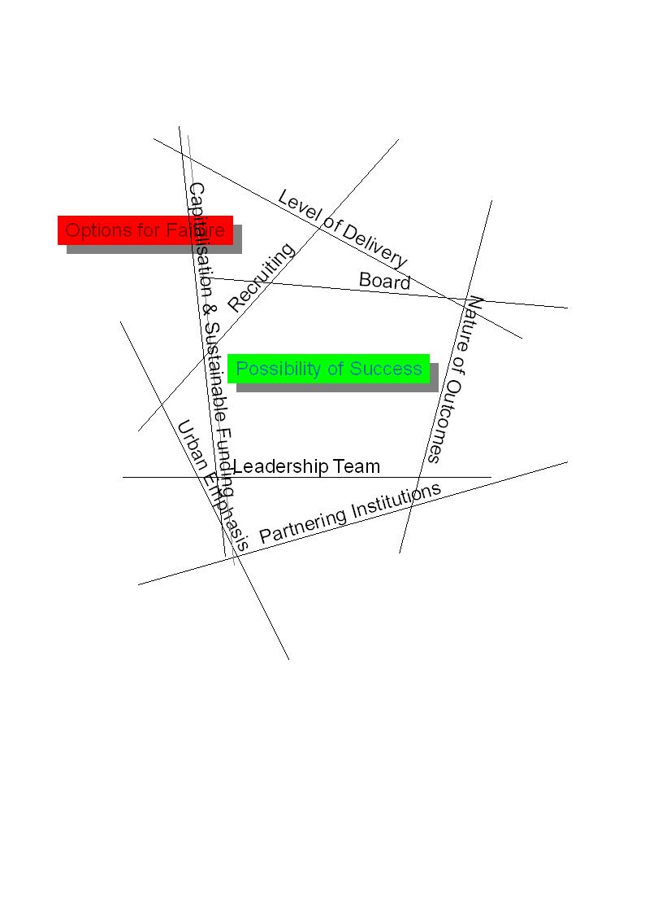
- What kind of national missional infrastructure within the Baptists can create collaborative sharing? for:
  - the values of evangelism, community penetration, identification, etc. What are the critical values that such a group would identify?
  - the apostolic/prophetic/evangelistic/ missional/ entrepreneurial calling
  - the intuitive, exploratory, community, collaborative leadership styles of such pioneer leaders and their teams
Do the Baptist need an alternative structure to the current one designed only for pastors (ie there are no ordained prophets, apostles, evangelists) to facilitate these as a special group of missional pioneers, protect them, enable them to ferment new values and approaches based on (at least in their minds) radically different lifestyles and values.
  - What kind of networked mentoring accountabilities would they elect to work with?
- How does a training network/hub/process relate with a training structureNature of Outcomes
- What Does a Kiwi churchplanter in a postmodern city look like?
- What does an ethnic churchplanter look like?
- What does an international churchplanter look like?
- What does a Kiwi entrepreneur, an apostle, a prophet, an evangelist look like?
- What sustainable network of such workers is needed?
- This would be a Training Hub/Institute/Network with its own life. It is self evident to most folks that it is simpler to develop this with educational partners/providers
- Leaders from Laidlaw College have consistently stated this is not an option as it is expanding in different directions than urban or churchplanting
- Carey is the logical denominational partner, as “handmaid to the churches”.
  - Can/will Carey partner with what is needed?
  - Do the churches want Carey to provide? (So far all I have talked with say this would be optimal, but for Carey to move this way they need to be sure this is a genuine request from the grassroots as well as from the denominational leadership).
- Can Carey partner with a learning network? Is there a champion for this among its current personell? Could they cut a 1-2 day role within someone’s job?
- Recognizing its transitions to be more action-reflection oriented is Carey now ready to work with action based training. (Perhaps the best way is to develop the action based courses as part of the Learning Network then draw from other courses within Carey that are more traditional.)
- How do relationships with Azusa Pacific University (Viv has pioneered a program with them - an MA in Transformational Urban Leadership ), Forge(Aussie postmodern churchplanting thinktank), DAWN, ALELON etc assist?
- Leadership capacity to integrate a core team
  - Who can give board level support in resourcing, policy, structure?
  - Are there a cluster of leaders (an abbot, a dean, an administrator) who would be available/willing to drive such a process?
  - Who are faculty who can deliver action-based training who have credible academic qualifications?
- With shared vision, core values, willingness to retrain in their style of education, commitment and availability, perhaps largely as volunteers
- Mother Churches
Classic New Zealand Baptist expansion has come from dynamic mother churches that have acted as resource bases enabling the hiving off of clusters of believers into newly forming suburbs. Though not the only model, it is likely that this model will continue to occur largely for logistical and manpower reasons.
Thus a critical question for the immediate research is which of the 241 churches have the capacity, vision, and commitment to be the base to send out a team of 5-10-20-200? Or which of the 33 over 300 members can be moved to envision and commit to such a task? If 20 of these have the capacity and 10 of these have the vision and will, they become the centres around which the training network is developed. Where are these, who are their potential catalysts and what would be their targeted churchplanting people groups or geographic areas? How do these targeted areas fit with the demographics of need that the Baptist Trust is evaluating from city councils, and the demographics of size/receptivity and response of migrant communities e.g. we know that 15,000 Filipinos have only 3 churches in Auckland but are highly responsive.
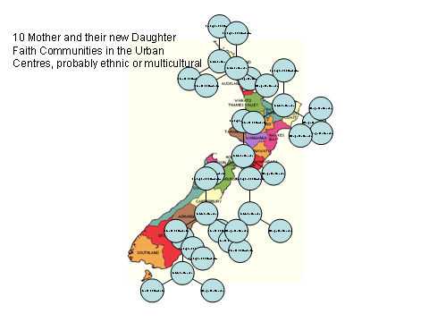
- Style (choose one)
- Mentoring Network
- Institute that localizes the national network, hosts couses and delivers seminars.
- Church-based seminar
- E-based learning with modular face-face courses
- Denominational Collaboration
- Do the NZ Baptists have enough residue left of their churchplanting heritage and the 60-80’s church growth expertise to move this or has the lack of church growth teaching for two decades left too great a vacuum of knowledge, and the lack of a church planting champion left too great a lack of skills levels. If so, is partnering with other churchplanting movements (Wesleyans, Apostlics? New Life?) and pooling expertise more likely to produce results?
- But if we did so would the Baptists eventually decide not to own this?
- Is the wisest approach to find a team of Baptist enthusiasts or to find a team of churchplanting trainers from across the nation.
- Recruitment: is the content adequate to recruit sufficient of the following for economic viability (18-25 new trainees per year)?
  - Ethnic Churchplanters and team members
  - Youth pastors moving on to their life calling
  - Pakeha postmoderns seeking to create alternative faith communities
  - Overseas churchplanters from Asia and Pacific cming for training
  - Preparing and returning missionaries
- Resource Base: this would likely take $50,000 start up capital per year for two years, plus students will then contribute half of the income by the third year
  - Who will drive the initial and ongoing resourcing process for this?
  - What would the denom, Carey, invest in it?
  - Where are there motivated national investors
  - What partners from external to NZ resource bases are possible partners
- Rules for a Successful Start up
  - Need 3-4 person leadership
  - Need adequate start up capital
- Is it sustainable long-term?
- Urban Future
- All population growth globally will be urban
  - All (almost)urban growth in NZ will be migrant including significant ethnic
- All (almost) new churches are urban
  - Most new urban churches are migrant urban poor and ethnic
- Thus future world missions needs to largely be urban
  - World missions needs to target the migrant urban poor
Should this training hub have an urban, ethnic and migrant poor focus?
- Preferred Names?
- Hub/Institute/ Learning Network?
- . Initiating New Faith Communities? Churchplanting is too structuralist term for a modernist generation. It will not market in a postmodern setting
- Urban: critical in recruiting
- Leadership: The focus is communal, apostolic, entrepreneurial leadership
- Expresses both alternative and Historic: We are seeking to form new faith communities which have a multiplex matrix of styles, but utilise 40 years of church growth thinking as well.

Shift the lines representing these issues on the above diagram to see the shape of things to come. These are open questions. But sometimes such discussions also work best if we start with some models and modify them. The following proposal gives a possible configuration to some of the questions above, plus alternatives.

Consultative Groups
We are planning to pull together a series of small consultations with folks with vested interest or expertise Feb-May. Let us know your interest and any others you would suggest should join and any thoughts on the above to begin with. I will also add you to our discussion list and plan four rounds of emails as the discussions progress.

 | Possible Dates | Potential Coordinator
South Island |  | Murray Robertson
Wellington Region |  | Rod Macann
Auckland-Waikato-Tauranga |  | ?
Tranzsend and ex missionaries from the 800 NZ Baptist missionaries not with Transzend |  | Peter Mihare  Jamie
Carey |  | Laurie, Brian Crum?
Strategy Group |  | Rod Macann
Ethnic Leaders |  | Alan Utting
Posmoderns |  | Aaron Minnee? and Nigel Cottle
My role is as a servant strategist/prophetic/apostolic catalyst without significant vested interest. What I have done over the years in launching ministries is work to create new visions, draw in those who want to move them, and help them determine possible initial structures, values, vision, resourcing. As the Lord directs, I am planning to move on by June, to keep creating training bases globally.
Yours in Him as we constantly create communities of love and faith,
Viv Grigg, BEE, MA, PhD
International Coordinator, Urban Leadership Foundation
P.O. Box 20-524, Glen Eden, Auckland, New Zealand
ph /fax +64-9-813-1440 SKYPE: vivgrigg
viv@urbanleaders.org www.encarnacao.org

Contents
Conversation about Training New Faith Community Catalysts 1
1.1 Background: God at Work 1
1.2 Outcomes of Listening Process 1
1.3 Maximising Critical Parameters 2
1.4 Consultative Groups 5
Model 1: 8
1. Summary 9
2 An Expanding Urban Nation 10
2.1 An Urban God 10
2.2 An Asian Pacific Training Centre 10
3 A Vision: Seeing the Impossible 11
3.1 Learning Community: Hub for Emergent Movement Leaders 11
3.2 Postmodern Style 11
3.3 Postmodern Values 11
4 Educational Philosophy 12
4.1 Relational Mentoring in Character and Skills 12
4.2 An Action-Reflection Degree 12
4.3 Practitioner-Teachers 12
4.4 Jesus-Style Intellectual Approach 12
4.5 Kinds of People We Will Train 12
4.6 Sources of Recruitment 14
4.7 Timetable 14
4.8 Distinctives 14
4.9 Course Descriptions 15
5 Start Up Plan 20
5.1 Leadership and Accountability 20
5.2 Launch Phase 20
5.3 Project Planning 20
6 Partnerships 21
6.1 Partnerships with Mother Churches 21
6.2 Partnership with Other Schools Globally 21
6.3 Other Partnerships 21
6.4 Partnership With Carey 21
7 Capitalizing Kingdom Expansion 22
7.1 Start-up Budget 22
7.2 Is it Sustainable? 23
7.3 Fundraising Plan (to be developed) 23
8 How Can I Make a Kingdom Investment? 24
8.1 Four Ways You Can Get Involved 24
8.2 Four Ways You Can Contribute Financially 24
8.3 What Will My Investment Return? 24
Appendix A: The Emergent Team: Which One is You? 25
Appendix B: Theological Position 26
Appendix C: Interfacing with Current Carey Baptist Training 27
Appendix D: Jesus’-Style Seminary in the Migrant City 31
Appendix E: Grassroots Training of Independent Church Leadership 32
Other Models: Various Network Styles to Build From 34
Appendix F: Some Literature 34
Summary

Model 1:

A Leadership Learning Community
Within the NZ Baptists
for
Creative Formation of New Faith Communities


Vers 23, February 2, 2009
Philosophy and Prospectus
Discussion Document
The attached is a modification of one plan that has been in development for a couple of years, submitted as an initial framework for discussion to various groups of stakeholders. Please affirm, develop, modify, expand, recruit resources, commit. We will then redraft it and explore over the next four months till something workable can be tabled.

Table of


Summary
Mission Statement
The Learning Community is an innovative mentoring and training hub for identification, development, and deployment of emergent missional leaders as they pioneer new faith communities in the cities of New Zealand, (& the South Pacific, Asia and the globe). It is neither a pastoral training school nor a theological training college, as it focuses on developing both the skills and knowledge of missionaries, church planters and evangelists for pioneering mission primarily within the postmodern and migrant ethnic urban contexts of New Zealand and the global megacities.
Distinctives
This Learning Community is unique in that it is a context of mentoring built around an action-reflection model that fits the practical Kiwi, and creates theologies that are realistic and engaged, and practitioners that are skilled yet thinkers. It is built around mentoring under experienced practitioners. Developing missional leaders involves very special types of entrepreneurial leadership training. Learners will include emergent leaders, migrant church-planters, business entrepreneurs, international students, urban poor missionaries, community development workers, and those sensing a call to pioneer ministries to the poor.
The Learning Community is unique in that it draws together an alliance of innovative church plants and mission ventures, connected to the ________ theological college, as well as sponsorship from the denomination and its agencies. Furthermore, the network is led by active missional practitioners and as such is able to offer significant experiential training in pioneering contexts while accessing academic accreditation from the training institutions (with student allowance for registered students).
Responding to the New Zealand Context of Urbanization & Postmodernism
The Learning Community has emerged at a time when it is widely agreed that we find ourselves in a new mission context. In our present cultural climate most experienced evangelists and missionaries recognise that intentional mission responses and church planting is the most effective approach. The Learning Community is a bold initiative which specifically addresses these challenges by linking experienced mission practitioners with emerging missional leaders. It aims to focus its energy on developing leadership that can understand the missional challenge and proactively develop strategies, approaches and teams, to be able to take the church onto new and uncharted ground.
New Zealand is increasingly urban (78.2% in 2006, increasing 1.4% that year). And thousands of migrants are turning to Christ. In Auckland, we are encouraging a dream to multiply into 25 new faith communities in the CBD over the next 10 years, In Wellington, Christchurch new urban communities have sprung up exploring what it means to be a faith presence in the city. But these experiments lack mentoring from the traditions and expertise of the global church in the processes and skills for new faith community formation.
Momentum
The Learning Community plans to offer an initial grassroots 2 years of training leading in time to a three year Leadership degree in partnership with ______. A Masters program has also been developed with three other schools globally by Urban Leadership Foundation, and students can do this in Manila, or Chennai, India, gaining accreditation from there or from Azusa Pacific in the US.
Already Urban Spirituality, Formation of Faith Communities, Kingdom Economics courses have been informally offered. The planned launch of the Learning Community is the first semester, 2010.
Investors
Partners are needed to gain critical momentum. The Learning Community needs a group of Kingdom investors to donate $100,000 start-up capital. Self-supporting faculty, members for the Thinktank, and for the future Trust Board are other forms of involvement.

An Expanding Urban Nation
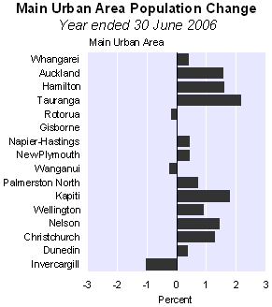
At 30 June 2006, the estimated resident population of the 16 main urban areas was 2,992,200 (72.3 percent of New Zealand's population). A further 245,300 people lived in secondary urban areas (5.9 percent of New Zealand's population). Auckland Urban Area contained 52.6 percent (1,260,900) of the North Island main urban population. Christchurch contained 62.6 percent (372,500) of the South Island main urban population.
For example, Auckland City is a melting pot of peoples. The CBD population is projected to grow to 141,800 people over the next 20 years from 181 ethnicities. As the city struggles to welcome its many peoples, cross-cultural communication becomes fraught with misunderstanding. Economic injustices are strongly felt by ethnic groups. Virtually no planned church-planting has occurred in the last 15 years in the CBD.

An Urban God
God is an urbanizing God, involved in the structuring of cities. History begins in the garden but ends with the garden in the city. The Urban Leadership Hub will offer grassroots and degree level training to form leaders to pioneer holistic and apostolic Christian faith communities (church-plants) in NZ cities, the South Pacific, and through returning international students to Asia.
We should expect to multiply 25 new congregations over the next 10 years throughout the Auckland CBD, 20 ethnic congregations in Wellington and Christchurch, 5 each in Tauranga and Hamilton etc. In every new planned suburb a new faith community should be formed. We should also expect that more than 100 missionaries will be sent back to Asia from converted foreign students, potentially resulting in 20 web-based movements. Critical in multiplication are two factors: leadership development and resourcing. The first largely produces the second.
The Process of Multiplying Movements

An Asian Pacific Training Centre
New Zealand, and particularly Auckland is central for many Pacific Island communities, so is a natural context for training evangelistic workers to return. These Pacific island paradises have seen the rapid expansion of slums in the main cities. For example there are Hindu slums in Suva, Fiji; Lae in New Guinea is notorious as a city of violent slums.
Migration has also filled Auckland with thousands of Chinese, Japanese, Koreans, Iranians and others. International student graduates returning to Asian and Muslim homelands need the skills to establish apostolic movements. If trained well, these will become effective church-planters and workers back in their countries.
Training of leaders who form teams, which form fellowships and churches.
Reaching the migrant poor with the Gospel requires intentional formation of Christian leaders with a transformational understanding of the Kingdom. On the other hand, aspiring postmodern Kiwi leaders need a think-tank as they formulate new postmodern faith communities.

A Vision: Seeing the Impossible

Learning Community: Hub for Emergent Movement Leaders
The expansion of the Kingdom of God requires multiplication. Jesus said ‘I tell you the truth, unless a grain of wheat falls into the ground and dies, it remains only a single grain. But if it dies, it produces much fruit.’ (John 12:24)
The vision is “to respond to the development of the NZ cities and global urban explosion by developing conversation spaces and mentoring contexts for servant leaders who will establish discipleship groups, multiethnic faith communities, and apostolic movements in the cities of the Asia/Pacific region, resulting in holistic Kingdom transformation of poverty, culture and society by each cell, fellowship, or movement.”

Postmodern Style
But what of drunken pagan Pakeha. In a postmodern context, we are required to work within Gen Y,Z paradigms and migrant tribal, peasant, and modernizing urban cultures.
We aim to achieve this:
- By creating environments where the missional imagination of God’s people is awakened, nurtured and developed.
  - We work with multiple models and styles of new faith communiteis determined by contextual dynamics and gifts-mix of the catalytic team and base
- By focusing on training for a distinctly pioneering type of ministry and leadership
- By stimulating a distinctive missional understanding and approach to church
- By coordinating an energetic network of pioneering leaders and practitioners focused on the task of mission
- By developing and operating internship style training
- By offering ongoing support and consultations to partnering churches relating to pioneering mission in New Zealand

Postmodern Values
We Value:
- a holistic approach to mission
- action learning approach to missional leadership development
- culturally-appropriate mission methodology in all settings
- a grassroots movement ethos
- a diversity of approaches and models according to each ones journey
- intentionally networked structure
- a passionate action-based spirituality
- creativity, innovation and experimentation in all we do
- modeling of leadership in mission
- coaching and mentoring
- an emphasis on community engagement in serving the needy, and uplifting the oppressed as the basis for speaking of the Master

Educational Philosophy

Relational Mentoring in Character and Skills
It is critical we build the training around four mentoring components: churchplanting, holistic ministry, business, and spiritual mentoring. The Urban Leadership Hub will build courses around such action processes to provide reflective contexts, some of which we expect will be attributable to a BTh in Applied Theology at Carey. Relationships are the primary means of transferring leadership and influence and are indispensable in the training of missional leaders.

An Action-Reflection Degree
Kiwis (New Zealanders) are practical people. This is a practical degree based around internships and mentoring. Each course is built from the stories of workers in action. Students will reflect on actions via theology and social theory, and then generate new actions. For example to learn language and culture acquisition students will be required to live at least four months in a Maori community, or in the slums of cities in the Pacific. There is an emphasis on living in poorer ethnic/multicultural communities.

Practitioner-Teachers
A person cannot teach what they do not know and they cannot lead where they themselves will not go. We expose our interns only to leaders who have a direct and current experience at a cutting edge mission, church plant, or ministry project.

Jesus-Style Intellectual Approach
Growth of the intellect is essential to missional leadership development. If we are to meaningfully engage our cultural setting we must first understand and interpret it. This requires significant intellectual development and skills. However, we believe there are other ways beyond the Graeco-roman system of the academy with which to develop an intellectual grasp of theology and ministry. Jesus utilsed action-reflection and storytelling learning of wisdom as his primary approaches. We follow a Freierian model of learning from the grassroots. We aim to engender a deep love of learning in all that we do.

Kinds of People We Will Train
Those with emergent gifts and capacities of:
- apostle

- prophet
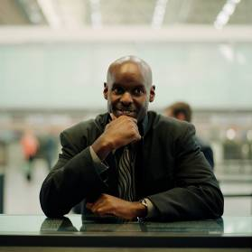
- evangelist
- Missional pastor
- Missional teacher
- deacon (social worker, community developer)
will move in a trajectory towards effectiveness in forming holistic apostolic faith communities, and in movement leadership.
Emergent leaders have some demonstrated ministry gift, call and fruit A leader becomes a leader. Natural giftedness is demonstrated in fruit. It is seen in commitment. It is seen in emergent leaders seeking cutting edge ideas

Types of Students
The student population will draw from:
- Emergent Youth: those sensing a call to the pioneering ministries or the urban poor or the elites but without extensive experience in urban ministry
- Migrant Church-planters: leadership team members in ethnic urban church-plants in Auckland
- Business Entrepreneurs who want to extend their skills into wider economic development of movement leadership among the urban poor
- Urban Missionaries preparing to be pioneers of new movements in cross-cultural settings among the urban poor in the poorest cities of the world
- Community Development Workers involved in church-based advocacy, community development or community organization processes within urban poor movements
- Professionals involved in government ministries, and business enterprises, or through professions such as teaching, journalism, development planning, and administration.

Student Outcomes
- Church-planters, Entrepreneurial Christian Workers, or members of church-planting teams: each student in the first year would initiate a small group, by the second year three cells, and in an optional, non-accredited third year internship develop these into a celebrating faith community.
- Entrepreneurs of specialist ministries: each student would work with existing organizations, helping to expand their ministries. Depending on gifting they would continue on to develop a specialist urban ministry, such as a drug rehabilitation program, or a credit co-operative.
- Potential missionaries and returning migrants: have both these pioneering skills and a formation in holistic Kingdom theology that relates to economic, political and justice issues. This training will enable them to develop cell movements / church-plants in situations of injustice and poverty.
- Professionals: use their sphere of influence in justice roles, or policy making. Or use their business or professional experience to socially, politically, economically and spiritually liberate the poor.

Outcomes
Over 10 years there will be at least 50 or more celebrating faith communities or new ministries (such as a prostitute’s ministry). This would not occur without a training school.
In the ideal we will train 15-25 leaders per year who:
- Commence 20 to 40 small groups of 6 to 10 persons per year
- Commence 5 to 10 new faith communities every year
- In 10 years, it is estimated that 100 workers will return overseas and 20 new church-planting movements will commence overseas

YEAR 1: Students and teams each initiate a small group (cell or ministry)
YEAR 2: Students and teams each initiate three groups (cells or ministries)
YEAR 3: In an optional, non-accredited internship develop these into a celebrating faith community.

Sources of Recruitment
The Learning Community is planning for 10 to 20 students in the first year:
- 3 - 5 international student who will return to their home countries
- 4 - 10 interns recruited from the Pacific, India and South East Asia, who will return to mid level management of slum movement leaders
- 3 - 5 existing leaders or team members of ethnic church plants
- 5 - 8 Kiwi leaders of churchplants from mother churches in the denomination
- 2-4 professionals in teaching, journalism, urban planning etc wanting to expand their professions to socially, politically, economically and spiritually liberate the poor through community organisation and community development (deacons)

Timetable
Summer School
TUL505 Language and Culture Acquisition
Year 1
Semester 1 |  | Semester 2
Subject Code | Course Title | Subject Code | Course Title
TUL500 | Writings, Reign &Urban Realities | TUL530 | Formation of Faith Communities
TUL520 | Urban Spirituality | TUL540 | Postmodern/Urban Reality and Theology
TUL525 | Communicating Faith and Group Multiplication | TUL560 | Theology & Practice of Community Economics
TUL550 | Service to the Marginalized
Semester 1-2
TUL570/870 Field Supervision I
Year 2
Semester 1 |  | Semester 2
TUL620 | Leadership in Urban Movements | TUL640 | Entrepreneurial & Organizational Leadership
TUL630 | Community Transformation | TUL655 | Advocacy and the Urban Environment
TUL625 | Educational Centre Development | TUL670 | Integration Seminar/Project/Portfolio
Semester 1-2
TUL660 Field Supervision II
Year 3 (optional internship, non-accredited)

Distinctives
Action among Migrants and the Urban Poor: Student learning involves the holistic empowerment of the migrant urban poor rather than merely providing professional credentials.
Leadership Development: This is a leadership degree not a theological degree, but it is profoundly theological. It will develop students’ leadership and managerial capacity under the tutelage of senior practitioners and educators.
Redemptive Social- Spiritual Movements: Training leaders who evidence the potential to catalyze or strengthen redemptive movements, large or small, through networking, coalition-building, and creative problem-solving.
Action-oriented: Theoretical study is integrated with experience-based learning so that students do not merely learn about urban realities, but are directly engaged with urban communities through each of their courses.
Conversational Theology: This is story-based supported by books. Learning is based from the stories of the poor and experienced workers. Engaging the stories of scripture will result in transformational conversations. Local theologies from among the poor are formed.
Incarnational lifestyle: Rather than being sequestered in an academic compound, students learn to enter the pain and problems of migrants and the poor.
Interdisciplinary. The Urban missions field is eclectic, integrating theology, the social sciences, leadership, history, and economics. Success is not in the mastery of one of these, but the holistic perspective on urban leadership that integrates these.
Mentoring: Extensive topical discussion, problem-solving, and supervision face-to-face with practitioner-faculty and students. Both delivery methods seek to enhance the exchange of concepts, and experiences in the analysis of urban poor issues

Course Descriptions
The following are courses already designed. Some modification will occur in discussion with Carey and other partners. Most courses are equivalent to 15 credits, which at 10 hrs per credit amounts to 150 hours work each semester. This is generally divided three ways equally between classroom time, individual study, and practical work.
SUMMER SCHOOL (15 credits)
TUL505 Language & Culture Acquisition (15 credits)
This course guides students in acquiring a basic level of language and culture competence within urban poor communities, and the knowledge and skills for ongoing learning. Students will be required to live with families and/or in communities (context to change year by year - Maori, Pacific Island) for three to four months. This will be supported by a weekly three hour night class. Students may choose to gain employment during the course. Learners complete language learning coursework prior to, or concurrent with courses below, ideally before starting the rest of the course.

FIRST YEAR (120 credits)
TUL500 Writings, Reign and Urban Realities (15 credits)
This course is designed to give an overview of the scriptures with particular emphasis on applying the biblical motif of the kingdom of God to issues of leadership development in resource-poor urban communities.

TUL520 Apostolic & Urban Spirituality (15 credits)
This course explores the development of a personal apostolic, evangelistic and urban - postmodern spirituality, as well as the skills of leading spiritual formation among the urban poor. The course includes a personal inventory of character, calling, and giftedness and addresses human development and family life in the urban context.

TUL525 Communicating Faith and Group Multiplication (15 credits)
This course enables the student to engage the gospel with postmodern society, and emergent ethnic peoples, establishing a small spiritual formation group with both Christians and non-Christians and examining the dynamics of discipling and group leadership. This involves student participation in a mentored church-planting team, supported by Field Integration and Supervision I across the first year of the degree.

TUL530 Formation of Faith Communities (15 credits)
This course emphasizes a story-telling approach to understanding the development of holistic churches in ways faithful to the values and goals of the kingdom of God. Entrance, proclamation, and discipleship are considered in relation to small group formation, leadership, and community development. This involves student participation in a mentored church-planting team, supported by Field Integration and Supervision I across the first year of the degree.

TUL540 Urban Reality and Theology (15 credits)
This course structures a dialogue between two processes, urban theologizing and social analysis (urban studies in economics, developmental studies, anthropology, sociology, history) in a mutually enriching interaction that generates perspectives and analytic methods for transformative urban mission (including urban research methods if not covered elsewhere).

TUL550 Service to the Marginalized (15 credits)
This course guides students in understanding the conditions of marginalized populations (e.g. street children, substance abusers, and sex workers), and in formulating a theology and strategy for team-based responses that aim to free individuals and change structural causes. This involves student participation in a mentored church-planting team, supported by Field Integration and Supervision I across the first year of the degree. Also see Field Placements Year 1 for practical aspect of course.

TUL560 Theology & Practice of Community Economics (15 credits)
This course introduces students to training urban workers in biblical economics, basic bookkeeping, business planning, savings cooperatives, and micro-enterprise. This involves student participation in a mentored church-planting team, supported by Field Integration and Supervision I across the first year of the degree. Also see Field Placements Year 1 for practical aspect of course.

TUL570 Field Integration and Supervision I (15 credits)
TUL660 Field Integration and Supervision II (15 credits)
These courses allow students to integrate their various practical experiences through an action-reflection process, mentoring, and supervision. The nature of each student’s church-planting/community involvement will be determined by their individual gifting, calling and capacity.

The courses involve integration of:
- Spiritual Mentoring: Beginning with growth goals developed in TUL520 Urban Spirituality, students choose a spiritual mentor to oversee growth across the degree.
- Church Planting Mentoring: An experienced church-planter works with the students over the two years of the diploma or degree. This oversees the student’s involvement as a leader or member of a church-planting team for TUL525 Communicating Faith and Group Multiplication, TUL53030 Formation of Faith Communities and TUL620 Leadership in Urban Movements.
- Business Mentoring: A business leader works with the student from the second semester in year 1 to the end of the degree to develop business skills in TUL560 Theology & Practice of Community Economics and TUL640 Entrepreneurial and Organizational Leadership.
- Experiental Placements: A field coordinator works with the faculty of each course and the student to coordinate, design, and balance field placements for TUL550 Service to the Marginalized, TUL625 Educational Centre Development; TUL655 Advocacy and the Urban Environment. Each position must (a) provide students with structured opportunities to address specific issues or problems in urban communities, (b) be under the supervision of a senior practitioner who agrees to guide, mentor and assess the service performance of the student; and (c) contribute at least 1/3 of the total expected course time

This may include the development of a Life Portfolio The portfolio is a place to collect achievements and a way of recognising success for life long learners. It is a showcase of what a learner has achieved through both formal and informal learning experiences. The portfolio contains work that a learner has collected, reflected, selected, and presented to show growth and change over time. A critical component of an educational portfolio is the learner’s reflection on the individual pieces of work (often called ‘artefacts’) as well as an overall reflection on the story that the portfolio tells. A portfolio can capture a learners entire learning history including written papers, assignments, multimedia work reflections, triumphs, and struggles, references and also indications of present and future career aspirations. -

SECOND YEAR (120 credits)

TUL620 Leadership in Urban Movements (15 credits)
This course explores the dynamics of leadership within holistic urban movements. Special emphasis is given to urban religious movement growth, family and “civil sector” organizational leadership models, and citywide leadership networks for evangelism, revival, and transformation. This involves student participation in a mentored church-planting team, supported by Field Integration and Supervision II across the second year of the degree.

TUL625 Educational Centre Development (15 credits)
This course trains students in the theory and practice of developing and improving education in the migrant communities (e.g. preschools, elementary, vocational, adult literacy programs, and IT centres) as integral to urban churches and community development. Topics include school effectiveness, models, curriculum, management, financial viability, and the school’s relationship to church and community. This involves student participation in a mentored church-planting team, supported by Field Integration and Supervision II across the second year of the degree. Also see Field Placements Year 2 for practical aspect of course.

TUL630Community Transformation (15 credits)
This course empowers leaders with the tools for releasing diaconal workers into community leadership. It includes an exploration of the challenges, models, analytic tools and envisioning for transformational change within urban/ethnic communities. Students develop a Christian framework for holistic development, community organizing, liberation and social change among the urban poor while gaining facility in community asset-mapping and initiating a seed project. This involves student participation in a mentored church-planting team, supported by Field Integration and Supervision II across the second year of the degree.

TUL640 Entrepreneurial & Organizational Leadership (15 credits)
This course provides practical experiences to unlock students entrepreneurial and organizational competencies required to initiate new movement structures among the urban and migrant poor. Students apply basic business principles and accountability systems in formulating a viable business plan within an urban community. This involves student participation in a mentored church-planting team, supported by Field Integration and Supervision II across the second year of the degree. Also see Field Placements Year 2 for practical aspect of course. [Prerequisite TUL560].

TUL655 Advocacy and the Urban Environment (15 credits)
This course explores the Biblical and practical approaches of advocacy. It anchors this in an examination of the relations between land rights and housing issues, and broader environmental problems, including natural disasters. Fieldwork focuses on advocacy for adequate housing and infrastructure services, and effective disaster response. This involves student participation in a mentored church-planting team, supported by Field Integration and Supervision II across the second year of the degree. Also see Field Placements Year 2 for practical aspect of course.

TUL670 Integration Seminar (30 credits)
Students apply the analytic frameworks and practical skills acquired through the MATUL program to an investigation of a specific issue or problem on behalf of a church-planting movement or community organization. Qualitative research methods are used to gather and organize pertinent information, culminating in the writing and oral presentation of a Professional Report that involves local residents in specific transformation efforts. (This may be replaced with a thesis if required by some accrediting bodies).

TUL565 Church Growth Principles
Add in her Bruce Patrick’s Church Growth course for all pastoral students.

THIRD YEAR (non-accredited)
Optional Internship
To gain further experience and to further ministries students may wish to stay on for a post-diploma/degree internship year.

An Option for some: Meshing the Learning Hub Training with Carey’s BTh
How could such courses interface with the Carey degrees? The simplest place to correlate these is with the BTh in Applied Theology. Within this degree, 8 courses in white below would need be created as conversation spaces by the Learning Network. The learning network would deliver some courses like MF500 and MM662, MM685 in their context also . Other courses in grey would be taken at Carey or at the Learning Hub as standard or modified Carey courses by those wishing to flesh out the training into a BTh.
NOTES FOR URBAN LEARNING COMMUNITY PERSPECTIVE ON CAREY BACHELOR
1: MB 6/732 The People of God is put in to meet Carey degree requirement of 15 credit level 6 in Theology.
2. MB6/720 Christology put in to meet Carey requirement of 10 B&T courses, and 30 credits B&T level 7
3: Fourteen Carey courses total that are required or that overlap URBAN LEARNING COMMUNITY courses. Plus three Full Year Field Education courses (equivalent to time of 3 courses), DONE PART-TIME. Leaves 7 courses to be inserted, two must be at level 7
4: Nine URBAN LEARNING COMMUNITY courses left. All fit into M&M strand
5: Two URBAN LEARNING COMMUNITY courses need to be dropped, or merged into other courses to meet spaces left. OR Two Carey courses need to be dropped.
6: Summary: Seven URBAN LEARNING COMMUNITY papers, plus 2 Carey papers relating to Churchplanting = 9 papers 7: Theology papers not in bold on planner show examples of papers needed

Start Up Plan


Leadership and Accountability
A listening exercise Feb-May is unfolding, where key players across the Baptist denomination are being consulted as to how to progress with these processes. From this a business plan, funding plan, partnership proposal will be submitted to key leaders in which the support and ownership of the project by the denomination is sought
It was decided to implement the Learning Community by starting informal courses in March 2008 (Urban Spirituality, Formation of Faith Communities Kingdom Economics thus far).

Launch Phase
The expected formal launch of the Learning Community is January 2010 (Semester 1). This launch phase is 16 months; Feb 2009 through to July 2010, with the first formal courses launched in February 2010. The entire start-up phase covers three and a half years. However if NZQA accreditation is not successful by December 2009, then the launch of accredited formal courses will be delayed until June 2010. Despite this, the program will continue to expand informally with or without the accreditation.

Project Planning
A sample of the discussion processes currently occurring:

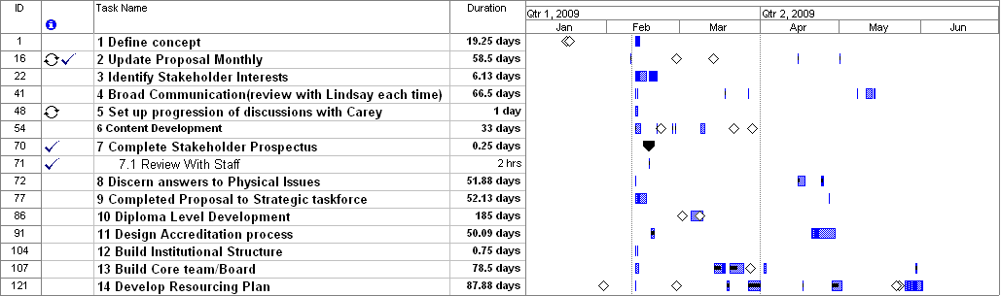

Partnerships

Partnerships with Mother Churches
Classic New Zealand Baptist expansion has come from dynamic mother churches that have acted as resource bases enabling the hiving off of clusters of believers into newly forming suburbs. Though not the only model, it is likely that this model will continue to occur largely for logistical and manpower reasons.
Thus a critical question for the immediate research is which of the 241 churches have the capacity, vision, and commitment to be the base to send out a team of 5-10-20-200? Or which of the 33 over 300 members can be moved to envision and commit to such a task? If 20 of these have the capacity and 10 of these have the vision and will, they become the centres around which the training network is developed. Where are these, who are their potential catalysts and what would be their targeted churchplanting people groups or geographic areas? How do these targeted areas fit with the demographics of need that the Baptist Trust is evaluating from city councils, and the demographics of size/receptivity and response of migrant communities e.g. we know that 15,000 Filipinos have only 3 churches in Auckland but are highly responsive.

Partnership with Other Schools Globally
How do relationships with Azusa Pacific University (Viv has pioneered a program with them an MA in Transformational Urban Leadership ), the Wesleyans (who also are actively churchplanting), Forge(Aussie postmodern churchplanting thinktank), DAWN, ALELON etc assist?

Other Partnerships
Ethnic Churches: There are over 500 new ethnic churches in Auckland, many independent, and increasing numbers on other cities. It is expected that a number of the leaders of these will be involved in this training.

Partnership With Carey
See appendix C for options for exploration with Carey

Capitalizing Kingdom Expansion

Start-up Budget
This project budget (exclusive of GST) is for each of 3 ½ years of the start-up.

 |  | Budget, Jan 2009
Income (NZ$) | 2009 | 2010 | 2011 | 2012
Starting Balance | 0 | 15,510 | 27,800 | 39,770
Grants – Raised
Base Church (Use of Facilities) | 24,050 | 18,250 | 26,850 | 26,850
Initial Setup Grants | 14,000 | 2,000 | 0 | 0
Grants – To be Raised on=ce
Businessmen | 50,500 | 53,000 | 12,000 | 12,000
Mustard Seed Grant | 8,800 | 0 | 0 | 0
International Partnership | 0 | 0 | 6,000 | 12,000
NZ Community Trusts (Equipment, Library, Scholarship) | 7,500 | 14,000 | 17,000 | 20,000
Total Grants | 104,850 | 87,250 | 61,850 | 70,850
Total fee income |  | 80,630 | 142,280 | 177,355
Total Income | $104,850 | $167,880 | $204,130 | $248,205
Expenditures
Setup Costs
Legal entity formation | 1,500 | 0 | 0 | 0
NZQA Consultant & Accreditation Fees | 9,000 | 6,000 | 4,000 | 4,000
Curriculum development costs for accreditation | 10,000 | 3,000 | 0 | 0
Equipment | 11,000 | 2,650 | 2,350 | 5,000
Library | 10,000 | 4,000 | 5,000 | 5,000
Staff salaries (6mos, 3 months before opening) | 18,000 | 0 | 0 | 0
Total Setup Costs | 59,500 | 15,650 | 11,350 | 14,000
Delivery Expenses
Salaries: Dean, Principal, Registrar, Librarian (all part time) | 0 | 79,400 | 98,050 | 116,650
Advertising | 2,000 | 3,000 | 3,000 | 3,000
Occupancy (by Base church) | 12,000 | 16,000 | 25,000 | 25,000
Supplies | 1,560 | 8,700 | 8,700 | 8,700
Fees | 100 | 500 | 500 | 500
Travel expenses | 2,000 | 3,000 | 3,000 | 3,000
To capital fund, depreciation, insurance | 200 | 5,500 | 10,000 | 13,000
Total Delivery Expenses | 29,840 | 139,940 | 180,810 | 202,650
Total Expenses | 89,340 | 155,590 | 192,160 | 216,650
To Reserves | $15,510 | $27,800 | $39,770 | $71,325
Note: Government policies require some student fees to be held in reserve to cover any catastrophes.

Is it Sustainable?
Three main areas will ensure the Learning Community’s sustainability. First, raising the 16 months start-up capital needed of $100,000 will give the Learning Community a solid foundation. A central city church is needed to freely provide facilities, equipment and time. The next steps are to recruit some businessmen, and to approach other organizations for funding (ASB, Lion Foundation, Auckland City Council, community trusts).
Ongoing financial sustainability after three years start-up will be from student fees: $80,630 in 2009, increasing to $177,355 by 2011, along with some scholarships. Government funding has not been factored into the budget as this depends on NZQA accreditation (and is subject to major political gyrations).
Organizational sustainability will also be ensured by partnership with _______ as educational provider, the quality of people being recruited as Dean, Principal, and Administration Assistant. Within the year, the partnering church or denomination will need to set up a separate trust to include members from the base Church, from Carey, from the denomination and three to five other outside members. This will ensure accountability financially and otherwise.

Fundraising Plan (to be developed)

Initial Presentations | Date to send | Amount
- Develop Christian presentation by putting in for _____ Foundation funding |  | 7000
- Prepare secular letter of enquiry and presentation
- Redo Christian presentations for potential business donors
- Rework for church leaders |  | 5000
Access NZ Trusts
- Identify potential trusts
- Put in for ASB (2 days) |  | 2000
- Evaluate 3 Community trusts (2 days) |  | 5000
- Baptist Tabernacle Trust (2 days) |  | 50,000
- City Council (2 days) |  | 3000
Access US Trusts
- One foundation |  | 15,000
- One partnering denomination |  | 20,000
Access NZ Businessmen
- Have key leader set up meeting with businessmen to capitalize $3000-$10,000 each. Who will set up? |  | 20,000
TOTAL |  | $x,000

How Can I Make a Kingdom Investment?

Four Ways You Can Get Involved

- Planning Committee: needs those with expertise, experience and energy. This will split and form into the Urban Leadership WalkTrust Board and a Working Team

  - Trust Board: will be involved in further envisioning the Learning Community, forming partnerships, recruitment of staff, and fundraising

  - Working Team: will contribute to course design, fundraising, and recruitment of students

- A Team of Businessmen Donors: is needed to capitalise the launch

Four Ways You Can Contribute Financially

- A Scholarship Fund: $2000 per NZ student or $5000 for foreign students who come to study. This helps students as well as the Learning Community

- Set-Up Costs Grant: contribute between $5,000 to $20,000. Total needed is $100,000

- Awareness through hospitality: Bring together other potential donors for a meal and presentation

- Staff Wages: Staff will be paid half their salary from the hub and live by faith for their other needs, and need to pray in $30,000 per year each

What Will My Investment Return?
Investing in Urban Learning Community is a donation to a charitable trust, not a business. Donations are tax-deductible. The returns on your investment will be in terms of the expansion of the Kingdom rather than in dollars and cents.

There are three main areas where your donation will bear fruit:
- In the lives of students who become effective workers fulfilling the Great Commission.
- In the communities these future leaders will work with, both in New Zealand and internationally. Their sharing of the Gospel will create new churches, and these churches will transform culture. They will each be planted knowing the values and problems of the culture of each ethnic community. For example: the course on community economics will result in the creation of small businesses. The course on service to the marginalized will result in churches reaching out to HIV/Aids victims. The course on Educational Centre Development will see schools established among the poor.
- In the establishment of an institution that produces on-going fruit. Capital investment at this time will enable a legacy of training to begin.
- Your investment will multiply. The churches, organizations and groups that will grow from this will not be static, but will reproduce. This is a vital dynamic in expanding the Kingdom of God.

Appendix A: The Emergent Team: Which One is You?

Role

Champion: The Driver of the Network

Chairperson: Board Motivator

Abbot: Driver of the Training

Dean: Expert in academic detail and partnerships

Administrator: The one who keeps the systems functional and develops the moodle based educational courses

Resource Builder: the finder of buried treasure

Faculty: Those who deliver each module

Function

The passionate strategic, apostolic leader who works with the churches to identify who, and where churches should be planted, identifies and deploys leaders, and makes sure resourcing and structural processes are in place.

Sage diplomat, who recruits, builds a board where members actively extend portfolios

The team Leader: An experienced churchplanter who knows how to draw out the best in the trainees, how to mould character, enable progressions of skills growth, identify gifts, deploys workers

Develops course outlines, handles NZQA, monitors partnerships with accreditation, handles faculty

Handles computer systems, finance systems, budgets, fundraising planning, student details, government business regulations

Travels and recruits business, church and foundation support, based on the fundraising plan affirmed by the board

Experienced practioners-reflectors in their fields, who are willing to undergo action-reflection training

Reimbursement

Half time

Voluntary

Half time

Half time

Half time

Voluntary

Mostly for love as they are involved in their ministries. Some reimbursement

Appendix B: Theological Position

We work within classic Christian beliefs represented by the apostles creed, but recognise that missional action is Biblically framed by an approach that prioritises evangelism as part of holistic engagement of the Kingdom of God with the world. As such we clearly affirm the Laussanne Covenant and the centrality of the Church as the primary agent of God’s mission.

We hold to the doctrinal values common among New Zealand Baptist churches

Appendix C: Interfacing with Current Carey Baptist Training
Carey used to be known as “the handmaid to the churches”. Every person I have talked with have indicated a preference to have such a training hub be developed as a separate institute with its own agenda, but in partnership with Carey. Given the current hiatus of principal, it seems advisable to frame what this might look like, such that any incoming principal has a proposal on his desk upon taking up the role. A major difficulty is that the Ministry of Education has determined that enrolment at theological schools must not expand. Carey is at its limit under this quota system with existing offerings.
From notes in earlier discussions to Laurie Guy, Acting Principal
After talking with you a couple of months ago I left with the understanding that:
- Carey as a pastoral training college has a clarity of focus on pastoral training more than in partnerships. However, the boxes used by the Youthtrain partnership in the BTh does provide the best potential model should any partnership be envisaged.
- It is a high risk situation for Carey to partner with a start-up training program. It is better for us to press ahead with developing the Leadership Institute, but seek to do so in such a way that partnership would be possible later on.
- Carey does not have excess resources to help in accreditation processes, although the knowledge is within the faculty as to how to do so.
I wonder if our developing the Leadership Institute would provide an interdependent school meeting the denominational felt need for urban and churchplanting training, without Carey needing to dilute or deviate from its stated directions. Such discussions involve a whole host of philosophical and structural issues.
Philosophical Differences: The following is a crucial set of statements. These arise from my role as one of a number of leading evangelical urban theologians and missiologists globally, representing the consensus of such leaders globally. Philosophically, an Urban Leadership degree is in significant disconnect with traditional theological approaches inherited from Catholicism, then through the reformation and into the modernist model of university education. The key points of disconnect amongst others are:
- Urban theology is based on holistic story-telling, not logisms and philosophy (although it engages these at upper levels). This is a different method of attaining knowledge to that of Plato and Socrates. It is also post-modern in style, and both can be seen in the example of Jesus and postmodernism of global cities.
- Urban theology is derived from action-reflection processes, not didactic downloads of information (see the attached article on a Jesus-Style Seminary for in appendix 3 for an expansion of this point).
- Mentoring processes are the primary mode of delivery of urban missional training. Course modules become supplemental to the character and action training in the program design. Thus we do not add field education courses – the whole degree is field education, to which informational modules are added for reflection and interpretation.
- Training outcomes for urban churchplanters / missional workers are dramatically different from outcomes for pastoral leadership training (see appendix 1 for further detail).
In the expansion of these points of differences into the design of training courses for churchplanters, a very different structural design of training is formed. Hence the major structural disconnects for any potential partnering College or Seminary. I have been working these through with four institutions in different parts of the globe (see the attached article on Implications of A Jesus-style Seminary: Radical Discontinuity in appendix G).
However a partnership or interdependence between the College and a Leadership Institute would, in my estimate, bridge the contradictions and facilitate a synergy that would be positive.
Viability of correlating with existing Carey course structures: In order to dialogue further, I have had Mel Cripps review the Carey structure for undergraduate diploma and degree against our optimal BATUL structures. She has done this two ways: From an Leadership Institute perspective and from a Carey Perspective.
While the Carey Bachelors has a few courses that would not necessarily be essential for an action-reflection based degree, its structure overall meshes very well. Combined with the Leadership Institute style of praxis-based learning and serious modification of the Field Ed courses, students would be trained with a strong focus on urban church planting supplemented by Carey’s Biblical/theological emphasis.
A significant point of difference in the LEADERSHIP INSTITUTE and Mission and Ministry courses is in how they are designed from praxis to reflection. Many courses have the student’s time spent equally between three different foci: 1. Class 2. Personal study 3. Praxis. The BA in Transformational Urban Leadership Field Integration & Supervision makes sure these are integrated and that mentoring processes for churchplanting, urban spirituality, and business are sustained across the degree
The LEADERSHIP INSTITUTE would need to retain a clear identity separate from Carey, based at the facilities at _______ , in order for the above philosophy of training and our identified training outcomes to be achieved.
Recognising these differences, I would like to explore with you and appropriate people:
- If Carey could work out a progression towards a partnership agreement with an Leadership Institute (at this point being catalysed by Urban Leadership Foundation, but with intention to be based as a Baptist trust based at ___________): as a partnering entity under a denominational umbrella
- We work to accredit the Leadership Institute program and courses as defined in the following diagrams under Carey’s NZQA and QMS processes, under appropriate guidance from a Carey expert in NZQA.
- Set up accreditation for the Leadership Institute students in the designated Carey courses, some of which would be delivered at Carey and some on-site at ______.
LEADERSHIP INSTITUTE PERSPECTIVE ON CAREY BACHELOR OF APPLIED THEOLOGY

MB6/732 The People of God is put in to meet Carey degree requirement of 15 credit level 6 in Theology
2: MB6/720 Christology put in to meet Carey degree requirement of 10 B&T courses, and 30 credits B&T level
3: Fourteen Carey courses total that are required or that overlap LEADERSHIP INSTITUTE courses. Plus three Full Year Field Education courses (equivalent to time of 3 courses), DONE PART-TIME. Leaves 7 courses to be inserted, two must be at level 7
4: Nine LEADERSHIP INSTITUTE courses left. All fit into M&M strand
5: Two LEADERSHIP INSTITUTE courses need to be dropped, or merged into other courses to meet spaces left. OR Two Carey courses need to be dropped.
6: Summary: Seven LEADERSHIP INSTITUTE papers, plus 2 Carey papers relating to Churchplanting = 9 papers
7: Theology papers not in bold on planner show examples of papers needed
8: MF500 Christian Formation would need to be modified into Apostolic & Urban Spirituality
9: Field Integration & Supervision I & II & III (for degree) would have to be made to meet requirements
10: MM662 Evangelism and Churchplanting taught by Bruce Patrick would become a year 2 course on Church Growth building on TUL530 Formation of Faith Communities
11: MM6/785 The NZQA requirements for Urban Mission would be modified for TUL540 Urban Reality and Theology
12: MB530 Introduction to the Bible would need to be modified TUL500 Writings, Reign & Urban Realities, which covers the same but from the perspective of the poor, the oppressed, the city, following Rob Bellingham’s materials
13: Can/should Field Integration be done as one course of 15 credits over 1 year rather than one semester? It would need to be upgraded to reflect the content of appendix 2
  - Summer school class TUL5/805 Language and Culture Acquisition. Carey does not have summer school currently.

Responses from Laurie have been positive, have helped to modify our thinking. I hope the following is an accurate summary
Carey is not in a position to respond at the moment as:
    - it is in transition between principals
    - It is limited by the current government limits on EFTS (equivalent Full time student numbers)
    - It is currently focused on expanding the YouthTrain process
    - It would envisage churchplantng processes being developed in some other way (not defined?).
    - It is easier for Carey to partner with something that is already in existence

Further Comments from discussions with past and present faculty
  - One suggestion is that a couple of Carey faculty be involved in each of the consultations leading up to the development of this training institute.
  - The churchplanting model proposed parallels the structure for pastoral students wbut with a different type of student and outcomes.

APPENDIX 5: CAREY PERSPECTIVE(?) ON URBAN INSTITUTE BA in TRANSFORMATIONAL URBAN LEADEDERSHIP
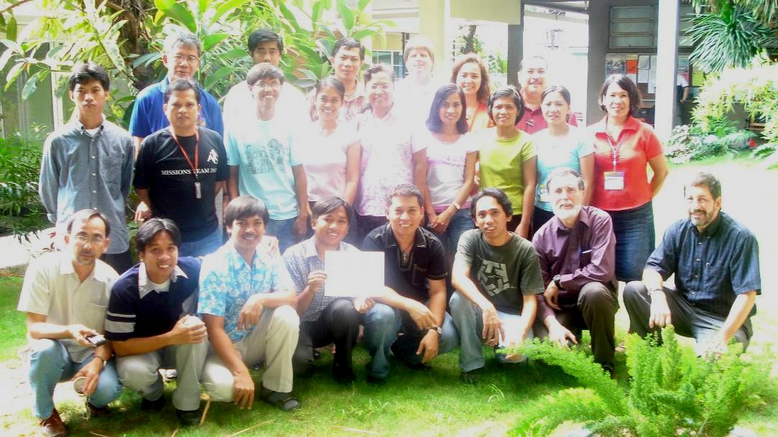

Appendix D:
Jesus’-Style Seminary
in the Migrant City

Viv Grigg, B.E.E., M.A.(Missiology), Ph.D.(Theology)
Where is the wise man? Where is the Scholar? Where is the Philosopher of the Age?.... Christ Jesus, who has become for us wisdom from God (1 Cor 1:20,30).
I was in Manila at the launch the MA in Transformational Urban Leadership, preaching about the passage above and the contrast between Jesus’ style education and the education of the academe. For Jesus was an educator - a brilliant mind. He recruited learners around him.

He knew of the Greek philosophic systems that Paul rejects here, and could have taught within them. For he grew up in the Decapolis, (10 Greek cities), lived 4 miles from Sapporis, one of these leading cities, where all the philosophies of the world crossed. He maybe built houses there. But he chose a different methodology for his educative process. It involved action-reflection more than philosophy, and built from the stories of the people, proverbs, and parables as these interfaced with God’s story and the conundrums of the trinity.

Following Jesus in the 21st C context, this MA is an action-reflection degree built around a process I call Transformational Conversations, a process of discerning truth through holistic story-telling. Some academics think this is not kosher. That truth can only be found through Platonic logic. Jesus was smarter. It’s the same argument Paul also is addressing.

His syllabus began with 40 days of prayer and fasting, so we begin with Urban Spirituality. Then in the power of the Spirit he began to preach, build a team and disciple, elements of Urban Poor Churchplanting. What he preached was the Kingdom of God, so an overview of the scriptures, Writings, Reign and Realities, with particularly referencing the Kingdom of God, poverty, oppression, societal structures, and other issues for slum dwellers.
Of course his declared focus was the poor. In fact, the next course is one on Rescuing the Marginalised – prostitutes, street children, drug addicts.
He understood the issues of the day. What do you think a rebel leader like Simon the Zealot and a tax collector discussed over supper along with ohn,the son of one of the leading families. Jesus discussed ways of understanding the signs of the times, so a course on Urban Realities and Theology helps students understand the context of the city and poverty.
He expected his disciples to bear much fruit. Movement Leadership grapples with multiplication. Jesus was very engaged with the rich. In fact, Nicodemus came to him because he was caring for the poor - issues of Advocacy and Justice connecting rich and poor, were important to him. And he was involved in healing, caring for lepers, thus a course on Primary Health and Caring for HIV/AIDS victims.
A quarter of his teaching was on economics, so Community Economics and a course on Entrepreneurial Management along with developing Slum Education, so that every pastor can train his eldership in small business and each church can become a viable economic unit and solve the property barrier through an associated school.
Jesus mentored. All these are taught by action-reflection methods, with a balance of extensive practicum, classroom reflection and guided readings. These are integrated with mentoring by churchplanters and by leaders of ministries throughout the degree in two Field Education courses. Since we do have to interface with the academe (descendent of Plato), the reflection is refined in a final Integration course project or thesis.
This is our humble attempt to follow Jesus’ style education in the slums, to get the seminary among the migrant poor of the city.

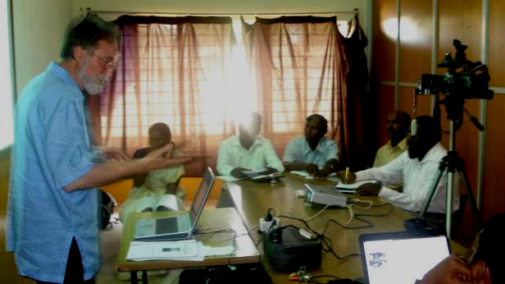

Appendix E: Grassroots Training of Independent Church Leadership
Rowland Forlong has for many years worked to train Brethren elders. Michael Hanson , formerly of Baptist College has been working with him to move this up a step with positive responses from Brethren leaderships. The following page gives their current training processes.
These are grassroots for elders not churchplanters per se (perhaps more in ine with the emphasis that Murray Robertson has been asked to bring with the Training Centre). The Brethren tradition is for non-accreditation academically but for the churches to accredit leaders as effective workers.
The structure is very similar to what is proposed above with an entrance course of self analysis which we have captured in the “Urban and Churchplanters Spirituality” course, then modules which are didactic and content oriented in the first column (equivalent to the kinds of courses available at Carey), and seminars which are praxis oriented in the second (equivalent to the praxis oriented courses proposed for an institute/learning hub.
We should explore utilizing the Life Portfolio as part of the integration course or field education course Perhaps alongside an academic integration project or thesis.
Is this a better model? Are there elements where we can collaborate with this process.

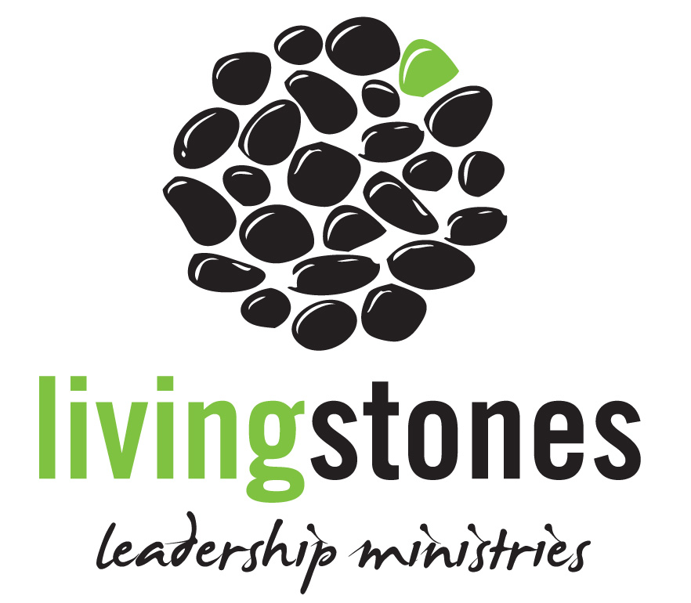
LIVING STONES
Ministry Development and Recognition
Living Stones Church Based School of Leadership

Ministry Qualification
Associate of Church Leadership
Life Portfolio
What Have You Done? What Are You Doing? What Will You Do?
Knowledge (Knowing) - On going training - Life Goals
- What have you learned - Current responsibilities - Life Planning
Character (Being) - Accountability - Future development
- What is your character like - Mentoring
Ministry (Doing)
- What have you done How You Can Prove It?
Artifacts such as sermons, lessons, photos,
certificates, letters, examples, references etc.

Teaching Modules
(5 Modules Required)
- Grasping God's Word *
- Integrating Theology with Ministry *
- Scanning the Old Testament *
- Scanning the New Testament
- Our Legacy
- Leaders Who Lead
- True Spirituality
- Preaching for Life Change *
- Pastoral Soul Care
- Doing Church in New Zealand
- Global Partnership in Mission *
Individualized student learning path depends on prior learning, experience & responsibility. Includes mentoring and accountability.
Seminars
(4 Seminars Required)
- Effective Eldership *
- Transformational Leadership
- Spiritual Mentoring *
- God-Centered Worship *
- Creative Preaching
- Healthy Small Groups
- Life Changing Youth Groups
- Transformational Children's Ministries
- Effective Women's Ministries
- Effective Mens Ministries
- Reaching Out to the Lost and Least
Development in specialist area to suit individual needs

* = Available in 2009

27-11-08
Church contact and student enrollment
Leading Like Jesus * (Required)
This includes:
- Analysis of the individual – knowledge/skills/character
- Beginning of life planning & portfolio
Accrediting Churches

Other Models: Various Network Styles to Build From
- http://allelon.org/ Steve Taylor is working with this network.
- http://missionalchurchnetwork.com/
- http://www.urbanexpression.org.uk/partners
- Evangelical Covenant http://www.covchurch.org/cge/church-planting They have a nice model of an effective denominational structure.
- FORGE (Australia) http://www.forge.org.au/ Their underlying philosophy is very similar to my own. Their ability to partner with existing training institutions is a good model. Their interdenominational commitment gives rise to the question, whether in NZ the NZ Baptists have enough expertise to develop an institute, or whether it would be better to do this in cross-denominational collaboration with other churchplanting groups?
- Morling College in Oz http://www.morling.nsw.edu.au/tinsley_institute/new_faith_communities/ have a simple structure of a new faith communities lecturer with some experience and network. My reflections on this are that the core person for training, need at least the equivalent of a Fuller MA or DMin with emphasis or some degree or mastery in church growth theory.
Web-based discussions and research
- http://www.echurch.co.za/ for dialogue on various matrixes for churchplanting.
- http://emrgnet.eu/wordpress/data/themes/ the emrgnet linkage of research on catalyzing churchplanting.

Appendix F: Some Literature
Becker, P., J. Carpenter, et al. (2003). Dynamic Churchplanting Handbook. Oceanside, CA 92052, Dynamic Churchplanting International. MATUL, Churchplanting
Breen, M. (2002). Ministry Guides - The Apostle's Notebook. Lottbridge Drove Eastbourne BN23 6NT England, Kingsway Communications Ltd. Churchplanting,Urban,Poverty
Brookes, N. and S. Curnow (1998). Lifting the Lid on the New Zealand Church. Shaping a Future. N. Brookes and S. Curnow. Adelaide, Open Book Publishers; Wellington, NZ: Church Life Survey.
Coleman, R. E. (1993). The Master Plan of Evangelism. Grand Rapids, MI, Revellbooks. (Discipleship as core Churchplanting)
Comiskey, J. (1984). Home Cell Group Explosion - How your small group can grow and multiply. 10055 Regal Row #180 Houston TX 77040 USA, TOUCH Outreach Ministries.
Conn, H. (1996). Planting and Growing Urban Churches. Grand Rapids, Baker Book House.
Driver, J. (1997). Images of the Church in Mission, Mennonite Publishing. (Theology of Church)
Eims, L. (1978). The Lost Art of Disciple Making. Grand Rapids, Zondervan Publishing house.
Garriott, C. W. (1966). "Leadership Development in the Multiethnic Church." Urban Mission 13(No 4, June 1996): 24-37.
Garrison, D. (2004). Church Planting Movements: How God is Redeeming a Lost World. Midlothian VA, WIGTake Resources.
Gibbs, E. (1978). Urban Church Growth: Clues from South America and Britain. Bramcote, Notts, Grove Books. U
Greenway, R. (1976). Guidelines for Urban Church Planting. Grand Rapids, MI, Baker.
Greenway, R. S. (1978). Apostles to the City. Grand Rapids, Baker Book House.
Grigg, V. (2006). Companion to the Poor. Monrovia, CA, Authentic Media (revised and updated), originally Abatross: Sydney (1984), revised MARC: Monrovia (1990)). revised Authentic, 2006.
--- (2000c). Transformational Conversation: Hermeneutics for the Post-Modern City. Auckland, Urban Leadership Foundation. MATUL, Reality, Churchplanting, Movements
--- (2004). Cry of the Urban Poor. London, Authentic Press.
Hesselgrave, D. (2000). Planting Churches Cross-Culturally. Grand Rapids, Baker Book House.
Hiebert, P. and E. H. Meneses (1995). Incarnational Ministry: Planting Churches in Band, Tribal, Peasant and Urban Societies. Grand Rapids, MI, Baker.
Hirsch, A. (2006). The Forgotten Ways. Grand Rapids, Baker.
Holland, D. (1996). Wakey, Wakey or Don't: Christian Church Trends in New Zealand. Auckland, St Stephen's Church, Ponsonby.
Hopkins, B., Ed. (1991). Planting New Churches. Williams Building, Woodbridge Meadows, Guildford, Surrey GU1 1BH, England, Eagle.
Jamieson, A. (2000). A Churchless Faith: Faith Outside the Evangelical Pentecostal/Charismatic Church of New Zealand. Wellington, Philip Garside Publishing.
Malphurs, A. (2004). Planting Growing Churches for the 21st Century: A Comprehensive Guide for New Churches and Those Desiring Renewal. Grand Rapids, Baker Books.
McGavran, D. (1970). Understanding Church Growth. Grand Rapids, Eerdmans.
McNeal, R. and L. E. Shaller, Eds. (1998). Revolution in Leadership: Training Apostles for Tomorrow's Church. Nashville, Abingdon Press.
Moore, R. (2002). Starting a New Church. Ventura, CA, Regal Books. MATUL, Churchplanting, Western
Neighbour, R. J. (1988). The Shepherd's Guidebook. P.O. Box 19888, Houston, Texas 77224, Touch Outreach Ministries Inc.
--- (1995). Where Do We Go From Here? A Guidebook to the Cell Church. Singapore, Touch Publications, Touch Resources #06-00, 66/68 East Coast Road, Singapore 1542.
Peterson, J. (1992). Church Without Walls: Moving Beyond Traditional Boundaries. Colorado Springs, NavPress. (Postmodern Church)
Phillips, K. (1984). . Out of Ashes. 2001 S. Vermont Avenue Los Angeles , California 9007, World Impact Press. Urban,Poverty,Churchplanting
Ringma, C. (1994). Catch the Wind: The Shape of the Church to Come. Sydney, Albatross.
Schaller, L., Ed. (1993). Center City Churches, Ministry for the Third Millennium. Nashville, Abingdon.
Schwartz, C. A. (2003). Natural Church Development. D-25924 Emmesbull, Germany, C & P Publishing. (Organic Churchplanting)
Stetzer, E. (2006). Planting Missional Churches. Nashville, Tennessee, Broadman and Holman.
Taylor, S. (2005). The Out of Bounds Church : Learning to Create a Community of Faith in a Culture of Change. Grand Rapids, MI, Zondervan. (Emergent Church)
Thwaites, J. (1999). The Church Beyond the Congregation. Carlisle, Cumbria, UK, Paternoster Press. (Theology of Transformational Church )
Villafañe, E. (1993). " Evangelizing Immigrants in Transition." Urban Mission 10( No. 4, June 1993).
Wagner, C. P. (1998). The New Apostolic Churches. Ventura, Gospel Light.
Wolf, T. (1980). Oikos Evangelism: Key to the Future. Future Church. J. Ralph Neighbor. Nashville, Broadman Press.

Appendix G: The Radical Discontinuity of Jesus’ Seminary among the Poor
Viv Grigg

Where is the wise man? Where is the Scholar? Where is the Philosopher of the Age? .... Christ Jesus, who has become for us wisdom from God (1 Cor 1:20,30).

(The following is included with recognition that Carey as a College has moved dramatically along the spectrum towards missional education, and integration of praxis within its didactic frameworks).

Among other things such as being God, Jesus was a brilliant educator, and director of a school. He modeled theological educational approaches among the poor. Traditional seminaries descended from the Western Platonic academe as it has come through Catholicism and the Reformation come from a different philosophy and practice. They may want to follow Jesus, but it requires a radical discontinuity. What opposition are you likely to find, if your seminary was to seek to follow Jesus in his simple philosophy and practice?
For hidden in the previous article on the style and content of Jesus’ Seminary in the Slums are some radical implications for the structure of seminaries. I have deduced these in italics below.
Mentoring
He recruited learners around him and mentored them in action. Mentoring as a primary educational mode as against mentoring as an additional element in a course of didactic learning is rarely seen across evangelical educational institutions except in areas of social work or urban missions or … Facilitators of such courses will be experienced practitioner-reflection leaders or will have to be willing to invest the time in being trained in these methods. Course location needs to be decided first, with a secondary location for reflection.
Action-Reflection
His style of action-reflection learning begins with engagement of the needs and the slum community. This leads to a period of reflection on the action resulting in a new theological formulation related to the arena of action. This could be a situation of oppression of the poor by the rich sending in bulldozers to take their land for condominiums, or a Ugandan slum pastor training 40 other pastors how to care for AIDS victim. Community, then classroom reflection on these issues each generates the formulation of aspects of slum-dweller’s theology. Action-reflection education will need to be lead not by an expert instructor but by an expert facilitator of reflection who can easily move back and forth from his/her base of expert knowledge to a mode of facilitative reflection on experiences. Each course will need to have facilitators with the theological skills to do this and the expert technical experience of the subject matter. This may need to be a combination.
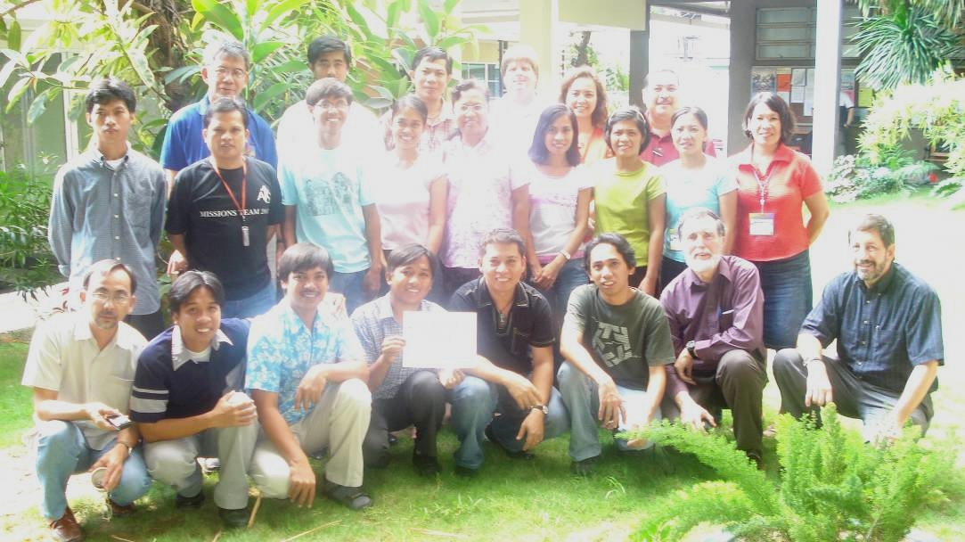
The implication is that after a brief introduction, each course begins with action and engagement, continues with extensive practica, then moves to classroom reflection and engagement with the literature. It is not surprising that Freire (1986) discovered this some centuries after Jesus. His paradigm-shifting educational ideas give academic validity to such a shift in style. The experiences of Latin theological educators, particularly the liberationists, who have sought to follow his approaches, gives some degree of modeling (success, failure, deviation), against which evangelical following of Jesus can be measured (See Van Engen (1994) for an evangelical extension of their hermeneutic cycle. It requires facilitators to write course outlines that first outline the practicum then the way the facilitator will integrate from practice to teaching and reading.
Location
Which indicates another dynamic – the location of Jesus’ theological reflection is first at the locus of the poor. Guitierrez and Boff were simply following 2000 years of radical discipleship when they brought that to the attention of the Latin theologians. One implication is that students be required to live among the poor (or next to the poor if conditions do not allow incarnational approaches but only identificational approaches (see (Grigg, 2004) for the issues in modeling of this)). Some encourage engagement in the daily life of poor communities. Engagement in daily night life is far more strategic. Facilitators for most courses also will need to have had extensive experience living among the urban poor. There are few theologians who have done this. Thus a whole new cluster of practitioner-theologians will need to be recruited, initially as adjuncts. I have had 30 years of experience with those who have not identified with the poor being vehement in their opposition of incarnational models. Justification of securities or even affluence is inherent in our humanness. Such opposition needs the grace of a St Francis. While the attacks are often vitriolic, graceful responses and small engagements into the slums of those who oppose is a wiser response than rhetoric. Faculties are brotherhoods and sisterhoods.
Truth Validation
Comparison of such theologies for validity is largely synchronic, as urbanization and the extent of urban poverty is a new phenomena. But both diachronic (traditional, historic) validation and synchronic (across cultures, present) require evaluation of the global literature. The implication is of a local to global reflection process. Local experience, local reflection followed by the facilitation of a conversation between that reflection and the global literature. Library facilities need to be stocked with both the local conversations and the global literature. There are a number of areas in the courses outlined where such literature is largely unavailable, still in oral form. Some new fields of knowledge will be developed.
Freire realized that the poor learn from their own stories. This MA is an action-reflection degree built around a process I call Transformational Conversations (Grigg, 2000), a process of discerning truth through holistic story-telling. Some academics think this is not kosher. That truth can only be found through Platonic logic. Jesus was smarter. It’s the same argument Paul also is addressing. How then do you retrain faculty from their experience under didactic methodologies into facilitators of conversations, built around webs of belief in a holistic manner (Grigg 2004b)?
Content
The previous article indicated that Jesus’ syllabus was very different to classical theology derived from Platonic/Catholic/reformation traditions. It began with 40 days of prayer and fasting, so we begin with Urban Spirituality. But spirituality in the slums has a major disconnect from classical spiritualities. It is noisy, emotional, full of direct encounters with the power of the Holy Spirit, with the weeping and orality of the damaged, and deliverance and healing are normative. Those trained in “spirituality” think they know the field but Western models of individual reflection and quietude, while significant and important for worker survival among the poor, are a world away. Which seminaries train people in direct work with the Holy Spirit in healing and deliverance? In character development from backgrounds of rape, violence, the psychological damage of poverty? What opposition would you expect from those trained in a spirituality based on individualism, order, quietness, the desert?
7 years of consultations across 20 cities with urban poor church-planters and movement leaders, and leaders of holistic NGO’s among the poor resulted in initially 23 courses reduced to 16 for manageability. But Rescuing the Marginalized – prostitutes, street children, drug addicts, Advocacy and Land Rights, Innovating Slum Education etc may seem far away from Hermeneutics, Homiletics, Systematic theology 1, 2, 3, 4, Church History 1, 2,3, Philosophic Theology. They are. And the distance will immediately invoke opposition. Are these theological courses? Why are they not already in our hundreds of years old curricula? How do we add these to an already full traditional curriculum? Is not a solid biblical knowledge and basic understanding of systematic theology a foundation for a contextual theology? (After identifying desired outcomes over some years from the grassroots, a Biblical overview was included as the first course in the degree - but it uses Rob Bellingham’s overview of the stories of the Kingdom in Genesis, Exodus, Leviticus... Revelations, as the Kingdom interfaced with creating a new community, turning a slave people into the people of God, deals with oppression, urbanization, etc…(Bellingham 2007). But we expect that each school, with their expertise, will add at least an introduction to theology course and some want to add urban poor hermeneutics, an introduction to missions, an introduction to world religions, some accrediting bodies want an extra paper on research, and academic English. It becomes a question of extending a 45 unit degree to 60+ for adult learners, leaders who already have ministries, are working jobs and leading families. So program directors have a fight on their hands to keep it within reason.
Secondly, holistic story-telling, what I have called “Transformational Conversations” as doing theology is a completely different way of grasping theological truth. The style with which we “do theology” instead of “think theology”, working in each course from multiple stories in order to find multiple perspectives, then contrasting those stories and perspectives with the Biblical stories to develop a transformational story - such a style does not have that refined book-learning centre, and does not follow Platonic logic. It follows a logic of discerning truth holistically through obtaining sufficient and sufficiently diverse but interrelated stories to identify a web of truths on a particular arena of knowledge (See Grigg, 2004). The Greek philosophers told us this was less than the higher truths of rationalism. Perhaps. But perhaps grasping primal understandings of truth in communal contexts is not a lower level of knowledge, but closer to the intuitive sensing of knowledge that some modern philosophers identify as near epiphanies.
Interface with Plato
This does not mean that “higher level” logic is totally rejected. We have to live with the reality that Plato also lives in the academe. There are some courses that may be better taught from this perspective. Jesus discussed ways of understanding the signs of the times, so a course on Urban Realities and Theology helps students understand the context of the city and poverty, and that requires some introductory understanding of complex issues and the logic behind them. Issues of Advocacy and Justice connecting rich and poor, were important to him. Certainly the Integration Project or thesis requires students to interface with the academe, so each course needs to train a masters student step by step towards capacity to write with logic. We are starting with poorly educated leaders, so the course coordinator will need to make sure that in the integrative field education courses each semester, there is personal mentoring in processes of logic and writing. Some schools will include this in additional English (or Portuguese or...) for academics courses.
Outcomes
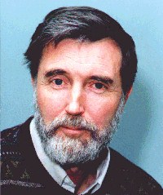
He expected his disciples to bear much fruit. The core of the degree is taking emergent or proven leaders and facilitating them into movement leadership skills. Movement Leadership grapples with multiplication. As such it has seemed best to position this degree as a leadership degree rather than a theological degree. We know that it is deeply theological after the theological method of Jesus, grappling with the whole of the scriptures in a conversational engagement across multiple fields. But since not all faculty would agree it seems simpler to set it to one side of the theological institutions as a specialist urban missions or urban leadership degree and since few faculty are trained in Jesus-style education to recruit a whole new bevy of adjunct facilitators gradually moving a core of them into full-time roles as well, in order to stabilize the program, and interfacing them with the traditional theologians so as to minimize the tensions. This is not an end-run around existing faculty for they will always be, but just a part of a process to sensitively move the balance from Plato to Jesus.
Implications
Re-Faculty
- Find new practitioner-theologians as adjuncts, then staff
Re-Learn
- Train new faculty in facilitative learning
- Train new faculty in action to reflection processes
- Untrain faculty in didactive classroom emphases
- Train new faculty in utilising of transformational conversational theology
- Train faculty around structuring mentoring experiences as a primary methodology
- Coordinate faculty in structuring practica for most courses (employ a coordinator)
- Train students with high intelligence, motivation and skills but little academic background into the logic of the academe over two years
Re-locate
- Require faculty and students to relocate in or near the poor
- Relocate both practica and reflection into the slums themselves away from the sacred halls
Re-theologise as a school
- Deal with conflict with existing faculty over the nature of Jesus-style theologizing vs Platonic-Catholic-Reformation-European academic styles
- Rethink theology in relation to the God of action.
- Learn transformational conversation techniques
Re-structure the school
- Probably set up the degree as a leadership degree outside the normal academic structures of the school
- Resist the pressures of existing faculty to load the degree with traditional courses till it becomes useless.

So, if your school believes it should follow Jesus among the poor, remember how he was treated by the theologians of his day and muse carefully before you leap. You may enter the forefront of education and theology unwittingly, with all the conflict inherent in pioneering obedience.

Viv Grigg, B.E.E., Dip. Teach., M.A.(Missiology), Ph.D.(Theology) has spent years pioneering works on the underside of megalopolises, seeking to understand movement leadership among the poor. He coordinates the Encarnacao Alliance of Slum Movement Leaders. The MA in Transformational Urban Leadership is being developed by a commission of the Alliance at the request of these leaders of church-planting movements and is being delivered by several partnering educational institutions. (www.encarnacao.org)

Viv, an NZ Baptist, is a global missions strategist, theologian, educator and community organizer. He brings to this process, 30 years of entrepreneurial action including personal expereince in pioneering five fellowships of various types in New Zealand and overseas; catalysing a number of holistic churchplanting missions out of which multiple organisations and several denominations have been birthed, (including Servants to Asia’s Urban Poor based from New Zealand); trained some thousands of churchplanters in cities globally, written books on the theology and practice of holistic churchplanting, etc, blah, blah. As an action-reflection educator, in the last few years he and colabourers has set up learning networks in several cities, and story-telling degrees to train churchplanting movement leaders in Manila, India and the US. A graduate of Fuller Seminary, he has a PhD in theology reflecting his primary roles are in the area of revival and societal transformation. The Spirit of Christ and the Postmodern City, analyses the responsiveness of New Zealand’s postmodern cultural context. He was one of the early pioneers of postmodern mission structures, so understands some dynamics of alternative mission. He struggles with helping 3 teenage kids survive in poor pagan West Auckland, and supporting his gifted Brazilian wife, Ieda, a motivational preacher and chaplain-grief counselor.
2? Churchplanting with its structuralist overtones is no longer a highly used term among post-moderns. Pioneering new faith communities is a term that allows for diverse structural outcomes, puts the emphasis where Jesus did on church as organism, relationships, team , community, while still emphasizing the need to create sociological expressions of faith and love. “Creating discipling movements” would be another possible alternative, but aims a bit higher than most Joe Blogs feel comfortable with.

