Jesus’ Seminary
in the Slums
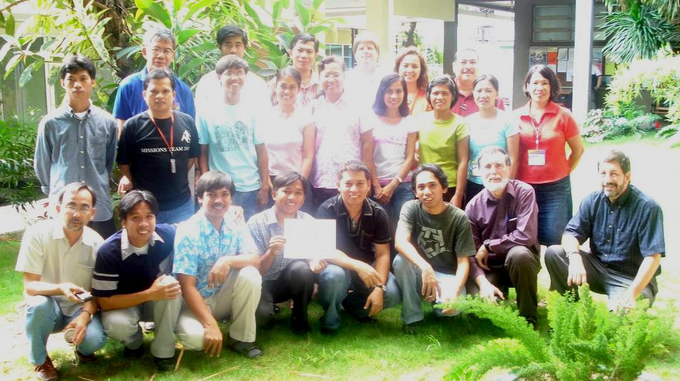

Where is the wise man? Where is the Scholar? Where is the Philosopher of the Age?.... Christ Jesus, who has become for us wisdom from God (1 Cor 1:20,30).

Jesus, Our Wisdom
Emmanual, god with us. Who is this man among the poor? Jesus, God who chose to be among the poor. Who is this simple man who would see his church established among the poor and the poor and poverty transformed? Jesus, who sat among people and told them stories, parables, proverbs. I want especially to speak of Jesus, the trainer, the educator.

I want to speak of Jesus, our wisdom.

I was in Manila at the launch the MA in Transformational Urban Leadership, preaching about the passage above and the contrast between Jesus’ style education and the education of the academe. For Jesus was an educator - a brilliant mind. He recruited learners around him. He apprenticed them, chose them to be with him, to learn from him as he was in action, then to be sent out to preach, heal and deliver, as he preached, healed and delivered.

He knew of the Greek philosophic systems of Plato and Aristotle and could have taught within them. Just as Paul could have. Paul later says, “Where is the wise man, where is the scholar? Where is the philosopher of this age?” and rejects this approach also. For Jesus grew up in the Decapolis, (10 Greek cities), lived 4 miles from Sapporis, one of these leading cities, where all the philosophies of the world crossed. He maybe built houses there. But he chose a different methodology for his educative process. It involved action-reflection more than philosophy, and built from the stories of the people, proverbs, and parables as these interfaced with God’s story and the conundrums of the trinity.

50,000 from the Slums to the Slums
For we have a mandate to bring this wisdom – this Jesus, who is wisdom - to 1 billion slum-dwellers. In 1989 for the Laussanne Congress on Would Evangelization, I calculated we needed 50,000 cross-cultural pioneers to the slums. No response. In 2002, I gathered 45 leaders of movements of the poor in Bangkok from around Asia, leaders of 300, 5000 churches, 300 slum schools,,. The Lord spoke to us through a prophet to prepare the way for 50,000 from the slums to the slums. We all said, “Amen!”. These leaders could see this as both necessary and realistic.

I was at the commissioning of 300 workers from Chennai, India to the North of India form a church of 13,000 mostly slum-dwellers. The godly old pastor prayed, “Bless you my children, go in the power of God, with the word of God, trusting in his provision, we are behind you.” And I said Amen, and inwardly remembered 1987 COMIBAM in Brazil, and 5,000 excited young people who went and returned defeated, penniless and frustrated. When a General sends an army he must train them thoroughly and provide pipelines of supplies. God, do not let this happen to these leaders.

In What do Leaders Among the Poor Want Training?
So I began to work on with our Global Encarnacao Alliance to focus on training processes for slum movement leaders.

The question is not, in what do we train workers? But what doe workers want to be trained in? Over the years, I have listened a lot and identified 432 things leaders among the poor want to know. I then broke these down into what apostles, prophets, pastors, teachers, evangelists and deacons need, and further broke these into 1200 outcomes of training in areas of knowledge, skill, character, and values. These came from 23 storytelling consultations in different cities round the world. I broke these into 12 modules at grassroots level and 23 modules at the level of movement leadership.

What do you think these 432 things would be? What are the top 5 thing you want training in? Please write these on a piece of paper and pass to the end of the row. Note your level of leadership and type of ministry.

Grassroots Training
The last couple of years we have worked with 2300 slum leaders in 21 cities to facilitate grassroots training out of which at least 19,200 have come to the Lord. How have we trained them? Not by teaching. Poor people don’t learn that way. But by bringing together story-telling consultations, where leaders tell stories to leaders.

e.g. I prayed that the Lord would lead me to a humble man among the pastors of Africa. In an unusual way, We were training 45 Pentecostal pastors in the slums of Kampala, Uganda. I began to teach on 9 principles of economic discipleship by getting them to tell their stories. For two days the debate raged as to whether they could leave their two sacred teaching of living by faith and tithing for teaching the broader 9 principles. They left and began to train their people in productivity and creativity, began to help them set up small industries…

Movement Leadership Training
But a second level of training is needed. This is needed to seed the 50,000 with 5,000 people of wisdom, with a comprehensive understanding of the breadth of issues needed to lead movements among the poor.

I watched this mixture in Brazil, when Pr Waldemar Cavalho sent teams of mixed Pentecostal and Presbyterian background. Those with education were able to give the interface with the middle class, the depth of theology. Those from among the poor were gifted and tireless workers among the poor.

Often I teach by simply asking a question such as: “What is a deacon?” This will take a days discussion as they unravel the reality that deacons do not give out hymnbooks at the door but are social workers, community development workers, highly trained. In Khmer, the language of Cambodia, the word in the Bible for a deacon is like the lowliest cleaner, and the word for a pastor is like a ruler. Unpacking these creates enormous discussion, then decisions about how to go about training a new kind of deacon.

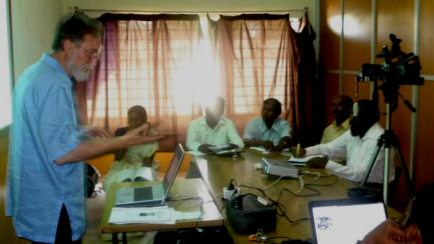
Following Jesus in the 21st C context, this MA is an action-reflection degree built around a process I call Transformational Conversations, a process of discerning truth through holistic story-telling. Some academics think this is not kosher. That truth can only be found through Platonic logic. It’s the same argument Paul is addressing. Jesus was smarter.

Jesus clearly defines those who graduate from his training. “The blind receive their sight, the lame walk, those who have leprosy are cured, the deaf hear, the dead are raised, and the goods news is preached to the poor.” (Matt 11:5). His syllabus began with 40 days of prayer and fasting, so we begin with Urban Spirituality. Then in the power of the Spirit he began to preach, build a team and disciple, elements of Urban Poor Churchplanting. What he preached was the Kingdom of God, so an overview of the scriptures, Writings, Reign and Realities, with particularly referencing the Kingdom of God, poverty, oppression, societal structures, and other issues for slum dwellers.

Of course his declared focus was the poor. In fact, the next course is one on Rescuing the Marginalised – prostitutes, street children, drug addicts. He understood the issues of the day. What do you think a rebel leader like Simon the Zealot and a tax collector discussed over supper along with the son of one of the leading families, John. Jesus discussed ways of understanding the signs of the times, so a course on Urban Realities and Theology helps students understand the context of poverty. He expected his disciples to bear much fruit. Movement Leadership grapples with multiplication. Jesus was very engaged with the rich. In fact, Nicodemus came to him because he was caring for the poor - issues of Advocacy and Justice connecting rich and poor, were important to him. And he was involved in healing, caring for lepers, thus a course on Primary Health and Caring for HIV/AIDS victims.

A quarter of his teaching was on economics, so Community Economics and a course on Entrepreneurial Management along with developing Slum Education, so that every pastor can train his eldership in small business and each church can become a viable economic unit and solve the property barrier through an associated school. All these and others are integrated with mentoring by churchplanters and by leaders of ministries in Field Education courses. Since we do have to interface with the academe, the reflection is refined in a final Integration course project or thesis.

This is our humble attempt to follow Jesus’ style education in the slums, to get the seminary into the slums.

