E. NETWORKS: Strategic Channels
Spiritual regeneration leads to moral renewal which leads to social transformation. A person that is a genuine Christian is a social agitator.
Every stage in these progressions needs not just vision, but channels for action, channels that first support the flow of vison and relationship, and then enable the flow of logistics.

Accountability for progress
An army will cease to act as a coherent whole:
- If relationships begin to break down
- If accountability is weakened,
- If there is insufficient logistical support, or
- If there is no effective feedback of information and hence poor decisions,
- If there is no measurement to mark what achievements have been made, then tactics may still be used in territory that would be better won by tactics more appropriate to the new situation.

Accountability can be sustained, even when all are working as leaders, voluntarily associating, yet operating mutually independent organizations when there is:
- mutual acceptance of shared goals,
- accepted patterns of combined action and
- affirmation of each others giftings and ministries.

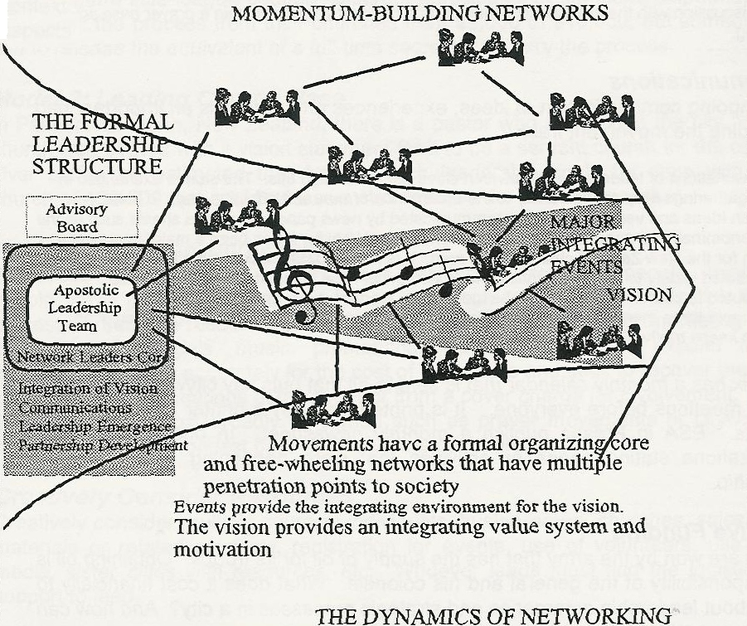

The City Coordinator needs to give:
- Clear definition of goals
- Clear integration of processes and target dates required (milestones)
- Regular times of consultation are needed evaluating progress to these goals by these processes at these milestones. During the consultative times leaders report back. The pressure of acceptance by the group, status with the group and honour for others that requires faithfulness in assignments are a strong component in an accountability structure among leaders.

Associated Network Coordinators
The coordinator of each existing network should be encouraged to link it in to the overall city network as an associated network. This then gives the Network Coordinator the right to use the logo, and slogans, or mottoes and access the credibility and teamwork of the wider association.

It is suggested that each network coordinator be responsible:
- to develop regular media communications to the people in the network and other leaders, generally a newsletter every three months.
- to develop a clearly defined leadership core team for the network, who make decisions together and hold each other accountable for progress towards collective goals, meeting at reasonable intervals.
- to plan a yearly gathering of the component groups of the network, where vision is expanded developments are celebrated and problems solved.
- to be involved in the yearly gathering of network leaders, and other in between meetings to account for progress made towards goals, and to mesh the network with others in the city.
- in discussion with the network core team to find ongoing ways to sustain a prayer base and funding.

COMMUNICATIONS
The ongoing communication of ideas, experiences and visions is an important part of keeping the movement fresh.

- Consultations of leaders in and between cities will encourage this. The stories exchanged in these gatherings may provide a key to the emergence of new and effective ways to build.
- Fresh ideas and ventures are also communicated by news papers and news sheets such as the interdenominational paper of New Zealand, Challenge Weekly. It has been a major source of growth for the New Zealand church in this area. It is nonsectarian, has its ears to the ground, and is circulated widely to all the churches and Christians of New Zealand. How much it has contributed to church growth cannot be measured.
- A simple three monthly news with stories and prayer needs, circulated among participating groups keeps motivation moving.

Phoenix has a monthly calendar that is sent to all that puts key citywide events and prayer meetings before everyone. It is printed freely by a printer for the publicity he gets. ESA in Fresno publish a monthly newssheet. In one I counted 43 organizations stating needs or activities that were happening in a sense of fellowship.

CREATIVE FUNDING
Battles are won by the army that has the supply of oil for its troops. Obtaining oil is the responsibility of the general and his colonels. What does it cost financially to bring about leadership emergence and strategic processes in a city? And how can it be resourced?

There is no single way to fund such processes. The city coordinator and the leadership team have to constantly keep their ears open to the Lord for creativity and their eyes on the budget for realism. There must be both faith and accountability to the Lord and men for the obtaining and use of resources. Funding is central to communicating vision, so do not consider it unspiritual.

Budgeting is a process of projecting ahead the costs and the cash flow needs that are likely to be involved in developing whatever strategy God is giving. Someone has to carry the administrative costs for each of the major components and their integration. This is an aspect of faithfulness in our use of mammon. Faith is in taking that budget and looking to the Lord for the means to see it happen. A wise man counts the cost before building a tower. Secretaries, materials production, postage, renting facilities - all these things are very costly, and very important and very down to earth. Jesus tells us that faithfulness in these small matters is a condition for spiritual leadership.

Model 1: Multiple Church Base
Len Zoetman in giving leadership to the Hope of Calgary process estimated that it cost them about $35,000 a year (the equivalence of a year's salary for a secretary) to do a low profile citywide effort. It felt like being in the big league advertising context with a little league budget. Different participants in the leadership funded aspects of the process from their churches from $5,000 to $10,000, but someone had to release the equivalent of a full-time secretary to carry the process.

Model 2: Leading Church Base
In Palmerston North, New Zealand, there is a pastor who is called to the city. His church was birthed with a vision statement for it to be a servant church for the city. Over coffee he estimated that funding such leadership could be done with a church of 450-500 that could release a staff member for such a process.

Model 3: Build Around Events
Processes are difficult to fund. Whereas events are exciting to people, involve people, have public outcomes and hence are much easier to fund. So link the processes, such as research, to key events. Utilize the events for marketing of publications, materials, music, promotional T-shirts etc., that expand the movement. Budget accurately for the cost of the events and seek to recover these costs either from donations at the event or from a cover charge for involvement.
Events that can most broadly be owned such as prayer movements or citywide crusades give the broadest base of involvement of churches.

Creatively Consider Resources
Creatively consider multiple sources: individuals, businessmen, churches, sales of materials or related products, registration for events, use of volunteers, use of media, sister cities with resources, etc. Whoever leads must find the logistical support to lead.
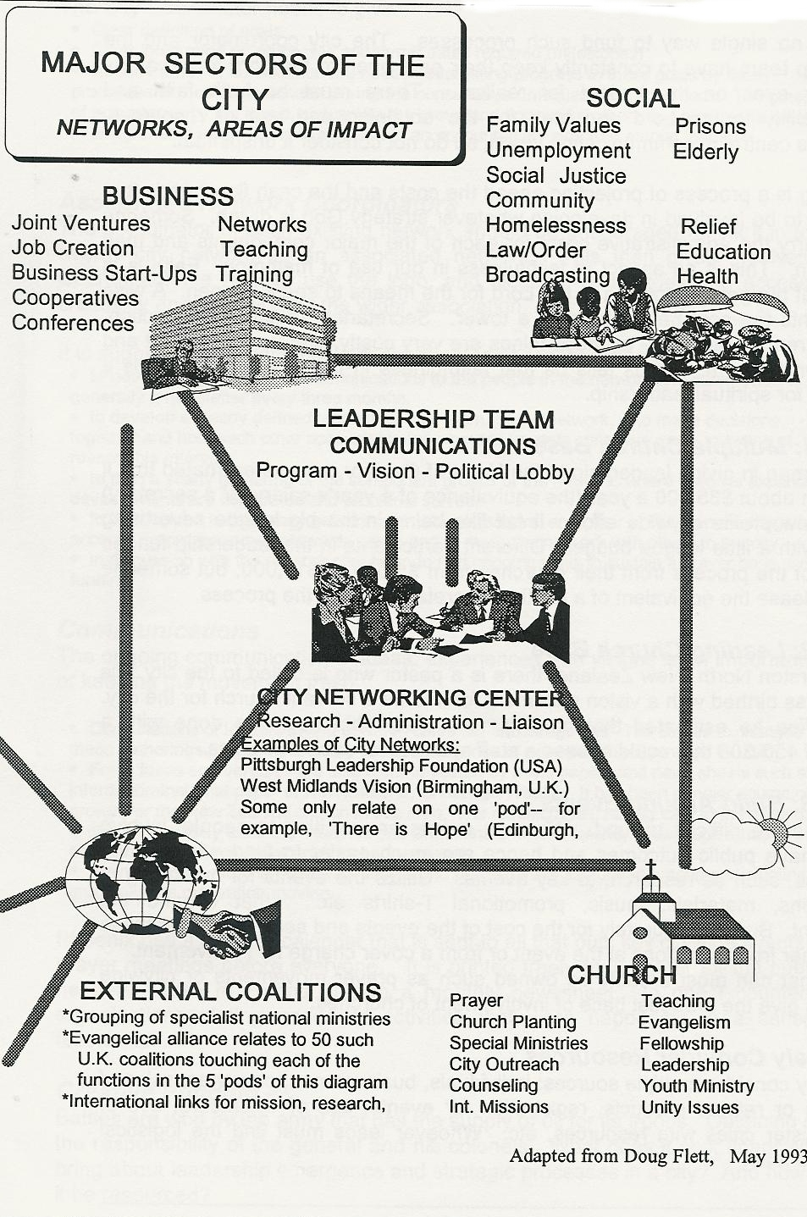
GOAL 1: WEB of Evangelism Networks
The following are some focus networks seen in some cities.

The responsive migrant poor
The Spirit of the Lord is upon me...
to preach good news to the poor...
to bestow on them a crown of beauty...
They will rebuild the ancient ruins
and restore the places long devastated;
they will renew the ruined cities.
(Isaiah 61:1-4).

Historically, ministries among the poor result in religious movements. Ministries among the elites result in societal and structural change. In most cities, the most responsive groupings are the migrant urban poor (though not skid row). The scriptures tell us these are rich in faith (James 1:5). They command us not to forget them. Sociology, and church growth research indicate them as the most responsive. They make up from 10-60% of your city. Any strategy for a city must biblically have a focus to the poor.

Since the central focus of Jesus' mission (and ours in Christ) was proclamation and that to the poor (Luke 4:18), the poor should be a central component of every consultation.

As leadership teams from 16 cities in India met together in Bombay and Delhi in 1994 and each city sought to define objectives towards the year 2000, again and again came the realization that many in their city were slum-dwellers and poor, and so each city emerged with a part of their strategy that defined how they would plant churches among the poor.
A needy-focussed approach to ministry causes the true pastors of the city to emerge. Men who have freely gone among the poor are understood to be true pastors. Others trust them. Involvement among the poor also leads to dealings with the rich as issues of injustice and inadequate city structures have to be addressed.

It is also important to seek out representatives for them in the leadership team. The development of a network of church-planters among the poor may be a key to new phases of ministry.

e.g. In Manila for four years now, the leaders of urban poor churches and ministries have been meeting together once a month. At these meetings two or three will share about their ministries, and issues of mutual interest will be discussed. From this has emerged a shared theology, and some shared understandings on strategic issues, plus the sharing of resources.

Neighbourhood Strategies
Some have developed small neighborhood prayer groups across the city. Ed Silvoso talks of a "points of light" strategy. Other have developed prayer triplets, and others "Houses of Prayer" for each street.

No citywide strategy will be effective unless it is rooted in small house group development. Some cities have a cell group pastors forum that fosters conversion from traditional churches to cell group churches.

Ethnic Evangelistic teams
In Abidjan, a research study of ethnic groups across the nation resulted in a series of maps plotting their density. As one flips through the maps it becomes obvious that for many of the people groups, their greatest concentration is in Abidjan. This resulted in a strategy of finding church members from certain ethnic groups such as the Fulanis who were attending different churches and asking them to work together in evangelistic teams to target their own people.

Musicians and Celebration Network
In Perth, Julie Spence leads an interesting Orchestra of Christians from many churches who over the last year have set up musical events and celebrations in 85 different venues.

Sports Networks
Sports ministries are in hundreds of cities. Sports Outreach, Athletes for Christ and others have developed high tech. approaches to integrating many city networks around evangelism at major events such as Olympics. The number of such global events is escalating exponentially into the 1990's and beyond, providing magnificent occasions for concentration of energy.

In a media culture, the high profile of sports heroes has a huge drawing power. In Auckland, 1996, a number of sports outreach personell met together, and setup open air meetings in a park, involving cultural performances by ethnic cultural groups, plus testimonies of leading sports figures. For the first time in many years open air evangelism in a post-Christian culture related to that culture. Of the 5000 who emerged from their isolated homes, 120 came to a new faith in Christ.

Youth Networks
Youth networks became the basis of the Aussie Awakening. Often they are a major factor in unity across a city. They are the base from which future pastors emerge. Linking them into the broader network is a service to the body of Christ that will bear fruit over the next twenty years.

A Village per Day
In many contexts the broad sowing of the word is the key to the explosion of new churches. In some cities, teams move from one slum to the next - taking a slum per day, then returning after a period to see if there is fruit remaining or to preach again until the seed is ripened.

Goal 2: Church growth and Planting

The Cell Church Movement
The emergence of leadership in churches is dependent on the leadership experiences they have in leading small groups. Movements grow in proportion to the small group dynamic. The lack of a cell church dynamic in a denomination indicates a future without leadership. Ralph Neighbour has developed many materials integrating theory and practice.
Church-Planters Network
Church-planting is tough. There is often little structural support in the denominational structure. Across the city it is healthy to try and bring these pioneers into support networks, perhaps around a training centre or series of thinktanks.

Goal 3 : Church Restructuring and Renewal
I am the vine, you are the branches
He who abides in me and I in him
He it is who bears much fruit
For apart from me, you can do nothing
(John 15:5)

Reconnecting the branches to the vine is a central element in turning a city to Christ. Every cluster of churches needs renewal. Each pattern of renewal will be different involving:
- divine intervention
- a doctrinal breakthrough
- simple new experiences and values
- a simple cell-like structure
- a coordinating cadre
- opposition from the established structures (not desired but a reality of new movements)

In cities where there are older denominations, sustaining and renewing them is a high priority which is often misunderstood or rejected by younger churches. To overlook this is to suffer the loss of hundreds of thousands of believers, as has happened for example across many of the cities of North India, or within the mainline denominations of most of the Western nations.

Don Douglas in Seattle has been developing the Millennium III Project, a plan to look at the issues facing the church into the 21st Century and define the nature of the church needed to respond to those issues. This looks at restructuring church life based on the renewing work of the Holy Spirit. Many renewal ministries focus on the renewal of the Holy Spirit, without always giving thought to the restructuring needed to sustain such moves.

Revivals last for a season - often 7-10 years historically. The fruit of revivals is dependent on the structures and theology put in place to sustain ongoing momentum and leadership development from them. They say the Welsh revival of 1904 died in the endless singing of magnificent Welsh hymns. Meshing the human and divine is an art, and an obedience.

The Denominational Leaders Network
This generally exists in some format. Sometimes it is a bishops gathering. They often are the "official" voice of the church on major moral issues that surface in the city. On the other hand here there are decaying denominations, often those elected into such positions are far from any commitment to the scriptures. At times they are active proponents of homosexuality or an anti-Biblical feminism.
Yet the role of this group can be redeemed. In one city, at the very meeting where I was presenting a vision of what processes could be developed in the city, the leaders of Pentecostal denominations were included in this gathering. A group that had been traditional, and quite liberal became suddenly infused with Biblical enthusiasm.

The Old Boys' Network
An issue that recurs in city after city, is the role of the remnant of leadership from twenty years ago. Often there is a group of very godly men and women, who many years ago were effectively leading the city. Over time they have stayed in formalized roles as leaders, some functioning effectively and some losing their way. They are godly men and women of the word of God.
Inclusion of such men and women into the process is extremely important if unity is to be sustained. Their blessing needs to be secured, advice considered. But generally it is men and women in their thirties, forties and fifties who will be leading the advance. They need the freedom to do so, without having to work according to older paradigms and structures. Often the emergence of new leadership threatens the existence of older structural groups like this. Gracious and sensitive handling of negative reactions is important if unity is to be attained.
Relating Multiple Committees
Marches for Jesus, Concerts of Prayer, Easter Celebrations and other events will develop separate committees, but there needs to be a harmonious meshing together of the ebb and flow of these activities through a relational dynamic among the leaders as they seek together to perceive how their ministries mesh together across the city.
Sometimes more formalized organizational partnerships over more extended periods of time may form, but they are rare and difficult to sustain relationally. Often these will occur between two organizations.

Relating to External Networks
Cities survive economically by import-substitution, imitating imports and creating new ones. In the same way, appropriate use of visionary or symbolic figures from outside can spark off a transference of ideas and new models into the city.
Clearly many of the networks mentioned above draw their dynamic and structure. from national or international movements, past and present. This is a positive, life-giving dynamic. However if the national or international movements come in to the city imposing their programs according to their vision and timetables, the process can become very difficult. The city leadership team needs a filtering system at times and discernment of the times and peoples.
Citywide Crusades: Use and Abuse
Citywide crusades, by invitation of the city leadership, involving the whole church, and at appropriate points in time in the battle for the city, may rapidly advance Christian unity and the impact of the gospel on the city, creating an environment for public declaration.

But in many cities, the major evangelists that come through, appoint their committee and have their crusade. In these situations there is rarely a concerted thinking through by the city leadership as to what crusade, and at what points in time crusades would help in the progress of the warfare for the city. Hence often there is insignificant impact on the growth of the city churches. Discernment by the leadership in unity can mean effective use of a crusade at the right time and with the right person.

Ethnic Reconciliation Movements
Alongside the Church/ pastors/ evangelism and the Transformation webs of networks is a third major grouping - the linking together of the pastors and leaders of the minority ethnic communities. There must be restoration in the city. Christ is the reconciler of all things. The church is the key to the reconciliation of the nations. The leadership of a city must pay attention to the issues between the peoples and make sure there is a team working on these issues, bringing down the walls. A first step in the process is a welcoming , uplifting, affirming process to these gifted leaders of migrant cultural groups who feel oppressed, rejected and marginalized, and whose people experience the same dynamic on a daily basis.

Goal 4: Transformation networks WEB
The gospel cannot be disassociated from culture. If the culture is moving towards Christ, the people will be open to conversion. Hence among educated people in Southeast Asian cities, there are rapidly growing churches meeting in hotels of English-speaking middle and upper class people who are becoming Westernized. As the cultural drift is Western focused, the perception is also that this is a move towards Christianity. In such a cultural drift, there is an openness to the reality who is Christ. In Western cultures that have turned away from Christianity, bringing Kingdom values into every arena of society is a recreating of an environment for turning the cultural drift back towards Christ.

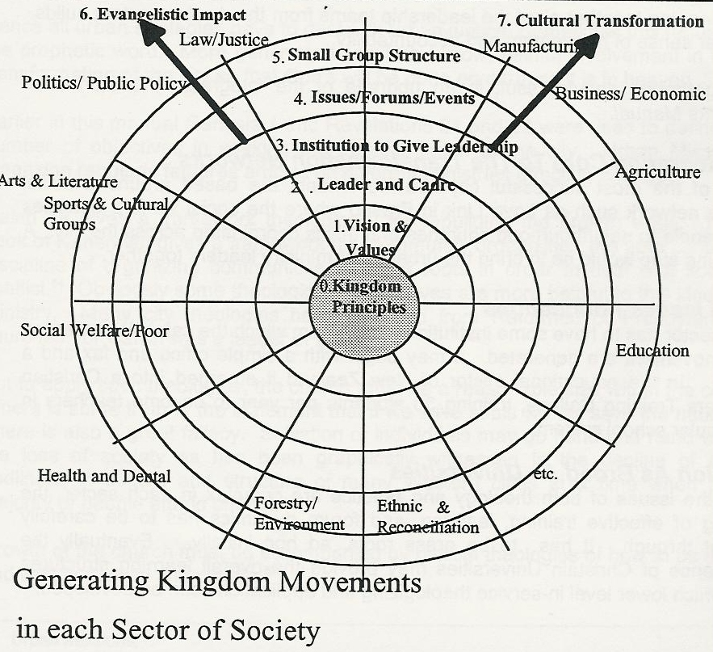
Each of the sectors of the city need to be impacted with the principles of the Kingdom. In each, the teaching of the scriptures needs to be spoken into the public domain.

To accomplish this:
- a catalytic leader for each sector must be encouraged to emerge
- a vision of how the principles of the Kingdom of God relates to this sector must be developed
- a cadre (team) sharing the vision and working for a movement dynamic has to be built
- an institutional nucleus sufficient to facilitate the movement dynamics
- creation of key events and related publications that publicly highlight issues and draw out key leadership
- a small group dynamic that enables both small group discussion of the Bible as it relates to the issues and an evangelistic dynamic that leads people to the Christ who is the solution and the integrator of structures
- coping with the opposition of the old order to the new movement

Synergism between the cadres (nuclei, leadership teams) from a number of sectors of society is motivating. A simple process of bringing two leaders from each of twelve sectors together (24 leaders) to share their vision, goals, milestones, and timing of key events can provide a supportive and accountable context, where each can build ideas from the models in other sectors. the integration of two page summaries into a manual provides a comprehensive overview into which to recruit others.

Then bringing together all of the leadership teams from the twelve sectors builds a further sense of momentum and accountability.

Each gathering should result in an upgrade of the integrated Transformation Networks Manual.

An integrating Core to the Transformation Networks
Some of the most successful citywide movements are based around a social welfare network such as Love Link in Fresno where the social welfare agencies refer people to neighbourhood churches and this is coordinated across the city. A beginning step would be to bring the urban poor ministry leaders together.

Moral Issues Foundations
Each sector has to have some institutional base from which the catalytic processes for a movement are generated. It may begin with a simple office and fax and a board. In the educational sector of New Zealand it emerged into a Christian Teachers Training College, training 30 students per year to become teachers in teh secular school system.
A Vision As Broad As Universities
Since the issues of both theology and practice are complex in each sector, the building of effective training, learning, and forum dynamics has to be carefully thought through. It has to be grass roots, ad hoc initially. Eventually the emergence of Christain Universities may provide the overall learning structures from which lower level in-service theologizing and applications can be developed.

Your Kingdom Come: Rebuilding the City
Your people will rebuild the ancient ruins
and will raise up the age-old foundations;
You will be called Repairer of Broken Walls,
Restorer of Streets with Dwellings
(Isaiah 58:12).
The Kingdom of God cannot be divorced from the justice of God in a city. Often evangelicals have not perceived that proclaiming the Kingdom of God includes proclaiming his justice, and his judgments. Nor can righteousness be assumed to be a spiritual issue alone. Righteousness in the scriptures includes a right relationship with God but also a right relationship with man.

Hence all urban strategies have to deal with urban justice. Sometimes this requires the prophetic word. More generally it requires a slow, painful involvement in the transformation of the city so that God's will be done on earth as it is in heaven.

Earlier in this manual Genesis 1 and Revelations 21 and 22 were used to define a number of objectives in seeking the transformation of the city. Urban Mission Magazine regularly features articles on different ministries effecting change.

Isaiah 58 gives a framework theologically for rebuilding the broken walls. The book of Nehemiah gives a framework for "community organizing," the 20th century discipline of organizing communities at grass roots in order to deal with social conflict. Obviously some theological perspectives are more helpful to this kind of ministry. Many city theologies have emerged from Reformed or Presbyterian churches, for Calvin was a leader of a city.

But to apply such theologies, the church must be a reasonable size within the city. There is some truth in the statement that if we save souls we will save the nation. There is also a great fallacy. Salvation of individuals may go hand and hand with the loss of society as has been graphically witnessed in the decline of the godliness in culture and structure of many Western cities at a time when the majority of people attend church.
Growth of the church must be accompanied by biblical theologies of how to be salt and light in society and culture.

Ongoing networks need to be looking at the issues of the Kingdom over the city and its impact on societal structures. Such a process requires looking at how the Bible relates to urbanization, city economics, political issues in the city, etc. Such theologizing is of use in speaking the scriptures into the context of the city elites and to those in power, and seeking conversion of the city leadership and through them the city structures.

The Pittsburgh Leadership Foundation has given a preeminent model of a progression from evangelistic ministry to a ministry that has impacted the structures of the central city including its renovation of inner city blocks. "Urban Ministry" in the U.S. has often been correlated with this kind of socio-political involvement, and this is a valid aspect of the impact of the gospel on society.

Bob Lupton has developed a model in Atlanta where an inner city community has been "saved", as all around the city has swept away viable communities. The sector of the church with these commitments needs to be part of the overall strategic thinking processes in the city.

One can consider 12 major sectors of society (or more) and look at a strategy for each one. Kuyper , a Christian theologian who became the prime minister of Holland earlier this century has done extensive thinking on the "spheres" of Christian influence, building off Calvin's work. YWAM have popularized his theology as the "7 mind moulders", looking at issues of how do you affect the mindset of a nation or city (for a nations mindset is determined in the city structures. An underlying concept is that "discipling the nations" involves bringing not just individuals but nations under the reign of the Kingdom of God. This is part of classical Catholic theology. Louis Luzbetak, a Catholic Anthropologist has been a reference source for missions leaders for decades in terms of the implications of the gospel as it penetrates cultures. Richard Neighbur has been a foundational figure in the Protestant theological circles establishing a philosophy of how the Kingdom impacts society.
Worksheet: Strategizing for 12 sectors of a city

12 Sectors | Vision of the Kingdom in this Sector | Leaders of Sectoral Movement | Institution to Bring Change | Nature of Cadres Small Cells, Evangelism Discipling | Ethical Issues to Be Addressed | Public Forums & Publicatns | Key Secular Leaders to Come Alongside Advise
Political/Public Policy
Educational
Ethnic/ Racial Harmony
Family/Youth
Law/Justice
Environment/ Forestry/ Land Rights
Business/Banking & Commerce
Manufacturing/Employers and Workers
Commerce & Media
Arts & Literature
Health & Dental
Social Welfare/Poor
Women in Leadership

For each of these sectors, at which points can the church have its most effective impact. For example we may break down into components the educational structure of a city-state. The policy (1) set by the governing parliamentary chamber (2), under the leadership of a secretary of education (3), is then set into operating procedures (4) by bureaucrats (5), and implemented (6) by educators (7). At which of these levels are there personnel and issues that can be impacted by the principles of the Kingdom.
For example, Alice Callaghan, a tough worker among the poor in Los Angeles, twisted the arms of some wealthy professionals and businessmen to come on board a scheme to buy up the decaying downtown hotels. She realized that the city first had allowed them to decay, creating havens for vice and drugs and violence. Then they condemned them and put up expensive building developments. The stock of housing for the poor disappeared step by step, forcing more and more people onto the streets. They remodeled them, cleaning out the drug addict and dealers, and creating an environment where poor people could live with dignity. Over ten years she has bought up 40 hotels.
The Strategic Leadership Network of New Zealand has brought a series of public figures from around the globe to speak into the secular arena from a high profile Christian perspective. Men like President Chiluba of Zambia who has sought to found his government on the scriptures to speak to parliamentarians, Micheal Novak a world-renowned economist and theologian to speak to the Business Round Table on ethics in business, Micheal Cassidy a leader in reconciliation in South Africa to speak to leaders from both Maori and Pakeha communities on reconciliation at a point where there are tensions.
What should each sector of the city look like in each sector of the city look like if under the Kingdom of God - education, politics, business, trade unions, manufacturing, the arts, city planning etc.? What values are important in this? What structures are needed to effect change? What personnel are needed? What symbols are needed in the political arena, the architecture, the media, the publishing in the city to communicate these values for each sector?
In all of this activity of seeking to see His kingdom established on the earth, we have our feet firmly on the ground understanding the nature of sin and its impact on both individuals and structural formations and our eyes fixed firmly in heaven and that city which is to come.
Abraham "was looking forward to the city with foundations,
whose architect and builder is God...
.[but] did not receive the things promised....
admitted they were aliens and exiles...
Therefore God is not ashamed to be called their God,
for he has prepared a city for them
( Hebrews 11: 10,13,16).

I saw the holy City, the new Jerusalem, coming down out of heaven from God, perepared as a bride beautifully dressed for her husband....Now the dwelling of God is with men, and he will live with them. They will be his people
(Revelations 21:2,3)
Come quickly , Lord Jesus,

This vision drives us on....

The Jesus March manual has an excellent section on funding a Jesus March
For a comprehensive strategy and theology linking ministry among the poor and reaching the city see: Grigg, Viv 1990 Companion to the Poor, MARC 1992 Cry of the Urban Poor, MARC
Silvoso, Ed 1994 That None Should Perish, Regal Books.
John de Vries of Mission21 India has some of the best developed materials on this. P.O. box 141312, Grand Rapids, MI49514, USA
Perth Christian Choir and Orchestra, 18 the Escarpment, Willetton, Western Australia, 6155, Australia
International Sports Coalition, 160 Harbour Drive, Key Biscayne, FL 33149, USA
The Australian Awakening has developed materials on over 70 different styles of evangelism in small booklet formats, 688 Parramatta Rd, Croydon 2132, NSW, Australia.
Neighbour Ralph 1995 Touch Ministries
Two useful books on these issues: Mead, Loren B. 1991 The Once and Future Church, Alban Institute, 4125 Nebraska Ave, NW, Washington DC 20016. Kelly, Dean Why Conservative Churches Are Growing,
Perkins, John 1995 Restoring at Risk Communities, CCDA, 1909 Robinson Road, Jackson, MS 39209, USA. John has a comprehensive perspective on reconcilaiton and rebuilding from within the American urban poor/ racially divided environment.
In an earlier book, I dealt in greater detail with issues of movement dynamics Grigg, Viv 1992 Cry of the Urban Poor, MARC
Urban Missions,
Linthicum, Robert 1991 City of God, City of Satan, Grand Rapids, Michigan: Zondervan Publishing House,
See chapter 11 of my earlier book, 1992 Companion to the Poor, MARC, for a development of biblical perspectives on involvement in political transformation. Noebel, David A 1991 Understanding the Times, Summit Press, expands Biblical Theology from an American perspective into 10 major areas of secular life in a well thought out and comprehensive 900 page book
Pittsburgh Leadership Foundation, 100 Ross Street, Pittsburgh, PA 15219, USA
Lupton, Robert 1993 Return Flight: Community Development Through Reneighboring Our Cities, FCS Urban Ministries , Inc., 750 Glenwood Ave, SE, P.O. Box 17628, Atlanta, GA 30316, USA
Luzbetak, Louis J. S.V.D., 1989 The Church and Cultures, Orbis Books
Neibuhr, H. Richard 1975 Christ and Culture, Harper and Row: NY

