“He started with nothing and rose to the pinnacle of the boxing world through sheer determination, faith in God, devotion to his family, and the support of a nation of people just like him—people who fight to survive every single day.”

How is it that one of the million uneducated children with the slum communities of the Philippines became not only a world-renowned boxer, but also the icon of a nation? Manny Pacquiao has become a leader and an icon to those in the Philippines due to his sheer determination and second to none work ethic, rising out of poverty and conquering his dreams. Pacquiao’s dominance and influence isn’t limited to just within the ring, but also in his multitude of different charities supporting education, nourishment, housing, and the many children in the position he once was. His rise to leadership was not however alone. There were many influential people in his life that aided him and taught him lessons that would be crucial to his growth and success in the world of boxing and congress. Every step of the way, the nation that he was fighting for, the people group he was supporting, continued to motivate him against all the tremendous odds he faced and is continuing to face throughout his journey. This is a closer look into the life of the humble, hard working Manny Pacquiao and his rise as one of the most modern influential people in the Philippines.

Childhood
- Manny Pacquiao was born into poverty in the southern Bukidon province of Mindanao in a city that had no pharmacy, doctor, or hospital. His family struggled to put food on the table and he grew up with the mentality that he had to live with “less”. [20]
- Pacquiao would go days without eating. Manny’s first job that provided food for his family by dragging in the nets from an old fisherman. Existence was a day-to-day thing [29].
- Pacquiao accredits his mother for his determination traits. She was a single unemployed mother raising four children in the slums, however she was still able to find a way to provide for them. She would stay up all night roasting peanuts so that he would have some thing to sell on the streets. [40]

- Life lessons learned by Pacquiao as a child that contribute to his leadership:
  - Never give into your immediate desires- While selling doughnuts on the streets, it could have been so easy to solve his two day empty stomach by filling it with the doughnuts. This would only provide temporary satisfaction and he knew he would be hungry soon again after. He knew that if he waited, the money would go towards feeding not only him, but his family. Self indulgence can hurt you and those around you [41] .
  - Never quit- While watching cockfights he noticed that the gallant birds never quit and would keeping fighting, even if that meant serious bodily harm or even death. These birds also taught him that you have to be quick on your feet and dig deep in order to reach your goals. [59]
  - Being successful once does not entail success forever- While watching the Tyson-Douglas fight with his uncle, Pacquiao realized that even the once greats can lose and that you always have to keep fighting to maintain your title. He learned that things aren’t just handed to you and that you have to fight (literally) for what you want [46].
  - The most devoted would be the most rewarded- He began boxing training with his uncle, a simple enthusiast with a lifetime of knowledge gained from watching fights but no professional training. This was the first major mentor in boxing and he would train day in and day out with him because it was his dream to become the nations best. [47]
  - Never take the easy way out- Even while starving on the streets, Pacquiao never begged for money. He would always work hard for food or minimal wages just so that he could maintain integrity. This has resonated with him throughout his career by not taking performance-enhancing drugs for boxing or taking from the country while in congress. [55, 155]

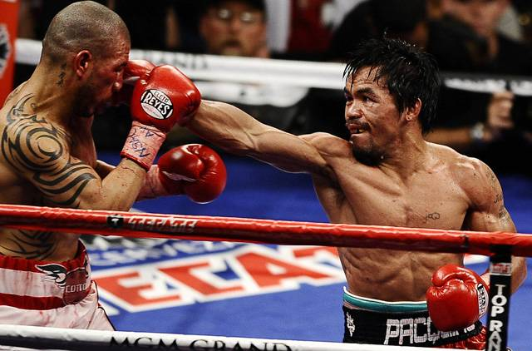
Pacquiao’s boxing career
- Pacquiao’s determination was the main driving force that jumpstarted his career. Before the age of 18, he went to compete in his first boxing match and had to put steel ball bearings in his shorts so that he would make the weight requirements.
- His determination and can do attitude is contagious and brought one of his friends out of the slums. He took Buboy Fernandez out of the slum, telling him that he was going to make him the best boxing trainer, and he did.
- In 2001 his boxing career took a giant leap. Seeing as he had already conquered the Philippines he took the invitation to go to the United States.
Pacquiao gaining yet another boxing title.
- Pacquiao met his main mentor, Freddie Roach, during his first trip to the United States. When they met, neither of them knew each other’s language, however they instantly became partners due to their similar intense work ethic.
- Pacquiao won his first fight against Lehlohonolo “Hands of Steel” Ledwaba and would quickly popularity in the boxing world competing against some of the best, most well known boxers including his boxing idol, Oscar De La Hoya.
- Manny Pacquiao is the only boxer in the world to hold 7 different boxing titles (now 8) in 7 different divisions, truly showing the extent of his dedication.

Pacquiao running for congress
- He first ran for a seat in the House of Representatives in 2007, however he was defeated by Darlene Magnolia Antonino-Custodio. She later stated in a press conference that, “More than anything, I think, people weren’t prepared to lose him as their boxing icon.” [173]
- Manny originally proposed free education and health care to the poor as well as supporting local fisherman with boats and a livelihood program, however he only campaigned for a couple weeks due to his robust boxing training.
- Manny ran for a congressional position in 2010. “I wanted to show my countrymen and women how people should be treated and that they shouldn’t stand for the corruption of their government taking advantage of them and using their tax dollars for the luxuries of the rich. I knew our government was, for the most part, corrupt and that most of the politicians who had been voted into office were taking advantage of our people.” [176]
- Manny campaigned with his wife and team feverishly for months directly to the people behind the fact that he was once just like one of them. He would go directly into the impoverished areas and reach out to them, explaining how he would address the lack of educational and health facilities in their area.
Manny and his coach, Freddie Roach.
- Pacquiao beat Roy Chiongbian on May 10, 2010 and won the seat in congress by a landslide.
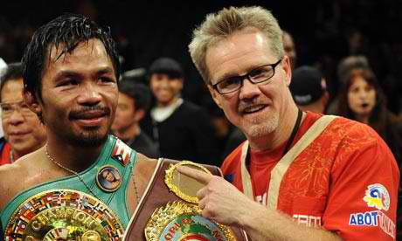
- “It was like all my life I had been giving to my country, and my country just gave everything back to me. They said, “Manny, we love you, and we trust you. Please make our lives better.”” [185]

Pacquiao and his leadership traits
- Creating and mobilizing disciples
  - Pacquiao can be noted for how he reaches out to people on a personal level and involves them, setting an example.
    - Manny reached out to Buhoy Fernandez, took him under his wing, and shared his knowledge of boxing to make him one of the best coaches in the sport.
    - Pacquiao reached out to the sisters of his wife early on in their relationship to win their approval even though he faced an uphill battle. [66]
    - During his campaign for congress, Pacquiao would go out into the provinces and cities and reach out to his countrymen. He created people movements to make aware all that was happening in the government and encouraged the people to stand up for what was right. “Then I would tell them, “That is not enough. There are many people who are not here right now. They can’t hear what I will do for them and how they are being taken advantage of by the government that’s in place now.”” [177]
    - It is hard to put a number on the number of individuals that Pacquiao has reached and influenced through his number of speeches. On a daily basis he provides others with and example of someone who has succeeded due to hard work instead of the easy route. “As soon as you take the easy way out, you will continue to live the “hand me more” lifestyle, and life will only get harder for you. Working for your food and shelter keeps you strong and builds character. This was a lesson that remained inside of me even when I was starving on the streets of Manila.” [55]

- Utilizing Team work
“I have learned that one of the best ways to keep from making the same mistake twice is to be surrounded by quality people. The truth is, we are only as good as the people we surround ourselves with, both in life and in business.” [105]
  - Manny is no stranger to teamwork or groups and has often attributed much of his success to these individuals.
    - Manny would not be where he is today with his boxing career if it wasn’t for his friend and colleague, Freddie Roach. Even the great Apostle Paul had the aid of another man, Barnabas, as he set out to plant churches in foreign lands. It was a team effort that got Manny his titles. “Pacquiao and Roach had won their first world title together, and it had happened almost in the blink of an eye. One moment they did not know each other; the next they were on top of the world.” [80]
    - Pacquiao manages large teams in both the United States (Team Pacquiao LA) and the Philippines, which promotes him for fights and other promotions. [74]
    - Pacquiao is also responsible for heading a number of different teams that run charities to reach out to surrounding communities. [109, 113]
    - Manny’s political career was clearly dependent upon the help and organization of a solid team in comparison to single handedly trying to campaign for his first political run. He utilized both people from the United States and the Philippines for his campaign and attributed a lot of success to Mayor Tani Pepito. [183]
    - Pacquiao states that it is important to surround yourself with quality people because they are the ones that can look at things from a different point of view and guide you in a better direction. [106]

- Focusing on everyone, not just himself (Servant Leadership)
  - Manny grew up as a child working to provide for his family and this mentality still hasn’t changed as he is striving to provide for his country. Without a doubt he is a servant and he leads from the knowledge he has gained through these experiences.
“As a congressman, one of my goals is to create opportunities beyond boxing for my fellow Filipinos by helping to bring billions more in other industries and commerce. I want to build my country as I have my career. I want to live for my country. I want to bleed for my country. I will bring my ideas to create opportunities for the poor—for the people with whom I shared a path.” [18]
    - Pacquiao serves his country through the Philippines Charity Sweepstakes, an organization that redistributes a lot of the lotto money into public organizations and development.
    - Pacquiao also has an organization that funds the education of over 250 children who are either orphaned or do not have money for education. [113]
    - He has kept his congressional promise of wanting to build public health facilities for poor communities and has recently funded the purchase of 360 American hospital beds, an ambulance, and the construction of housing to be utilized by a community. [113]
    - Even though he was training for one of his biggest fights against Oscar De La Hoya, Manny took time off to aid those affected by Typhoon Ondoy in 2009. He later pledged that after he completed his fight against De La Hoya he would donate one million pesos to those affected. He has now vowed to donate to a hospital in General Santos after every fight. [113, 170]
    - One of the hardest things Pacquio says to have realized is that love alone will not solve the issues of the Philippines and that it will be through education. He didn’t receive a proper education until later in his life and realized the importance of education so he set up a scholarship foundation that has aided over a thousand students. [170]
    - The Manny “Pacman” Foundation Inc. formed a medical team of over thirty doctors, nurses, and other medical staff to travel across the Philippines to hard to reach areas, reaching over 6,000 people and not leaving until everyone was cared for. [170]
    - Pacquiao also focused his attention on the United States and joined the effort to plant one million trees in Los Angeles. One thing that separates Pacquiao from many others is the fact that he personally participates in all his outreaches. [166]
    - In the midst of training for one of his biggest fights against Ricky Hatton, Pacquiao took the time to support the Breathe Again foundation in Orange County, going above an beyond his call of sponsorship and support. [166]

- Creating a goal and adjusting the path to reach it
  - Pacquiao has lived a life based off of dreams and goals. His original goal was to become the best boxer in the Philippines and then once he completed that he aimed to become the best in the world. There have been moments in both his boxing career and life where he has had to adjust in order to reach his goals.
    - After his first defeat in 2007 in politics it would have been easy to stop all together, however Manny stuck with his dream. He adjusted his strategy and began campaigning earlier and with and effective team. [127]
    - In 1996 Pacquiao faced his first defeat and came to life changing realization. “The truth is, if you do not have enough to offer and you cannot compete at your ability, then you are hurting your fans as much as you are hurting yourself. I learned to not force myself into a weight class I didn’t belong in.” [95]
    - Like any true leader, Pacquiao is open for change and willing to take the initiative and try something against the norm. It takes a humble leader to realize that their strategy is wrong and fix it.
    - “The three things you need to instill in your life are goals, a system to reach your goals, and the discipline to maintain your system until you reach your goals.” -Pacquiao [157]

Pacquiao and his faith/religion
Manny Pacquiao is a solid Christian believer and is constantly relying upon his faith and trust in God as he competes not for selfish gain, but for his country.
- “If you truly believe as I do, and your faith is so strong it cannot be shaken under any circumstances, then there is no reason to be nervous about anything in life. Faith and confidence go hand in hand.” [87]
- “God has blessed me with my abilities, and I give all the glory to Him. I try and let God use me as an example of what someone can be if they never give up, and if they work hard and believe in themselves.” [156]
- “God gave us everything to live in this world, so why don t we share with others?” [114]

It is clear to see that Manny Pacquiao is a face of a nation and a great example of a leader. Many of his leadership qualities stem from his early childhood and the many experiences that he has gone through. His leadership qualities are laced with determination and the characteristics of a faithful man. Manny does not box for selfish gain, but walks into the ring carrying the hopes and aspirations of his nation. Before each fight he doesn’t pray to win the fight, but he prays for both the safety of himself and his opponent. Throughout his life we can see how his leadership abilities has motivated others to serve and work at their highest capabilities, living up to their God given potential. His actions have aided not only his community and his country, but people all across the globe. Pacquiao is taking his leadership to a whole other level through his congressional position and he is not showing any signs of stopping there. He is taking direct initiative in serving those who do not have a voice and who are being taken advantage of, serving as a truthful leader in congress and possibly even presidency in the future [194].
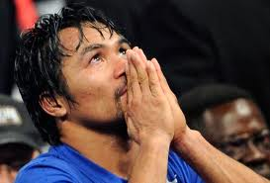

All citations and page numbers are from Pacman: My Story of Hope, Resilience, and Never-Say-Never Determination.

Pacquiao, M. (2010). Pacman: My Story of Hope, Resilience, and Never-Say-Never
Determination. Nashville, TN: Dunham Books.

